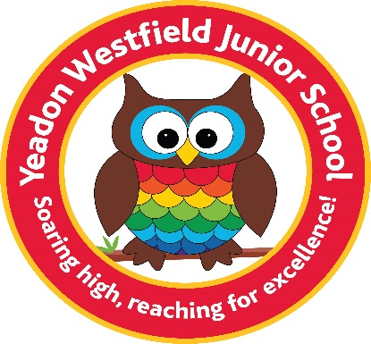

Our Pupil Premium Pledge
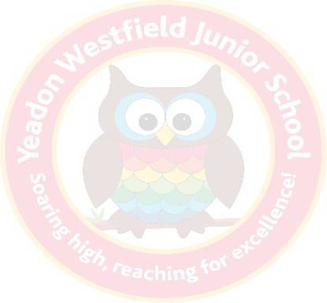
The Staff and Governors of Yeadon Westfield Junior School are committed to ensuring that learning and teaching opportunities meet the needs of every pupil, so that everyone makes maximum progress and reaches their full potential. We welcome and share the government’s aim of tackling all forms of disadvantage and will work tirelessly to ensure inclusion and equal access for all learners.
To that end, all our pupils and families can expect the following:
Excellent day to day teaching
Senior leaders work with teachers to increase the percentage of good and outstanding teaching. Research shows that high quality teaching has the highest impact on the progress that Pupil Premium children make. The Pupil Premium Lead will monitor the progress of the group.
Careful tracking of progress
Pupil Progress Meetings are held every term between class teachers and senior leaders where each individual child’s progress is scrutinised, and actions put into place to make sure each child is reaching their full potential.
In addition to this, our pupils and families eligible for the pupil premium grant can also expect:
Improving the effectiveness of interventions (Including Speech & Language)
By the appointment of an extra teaching assistant in school, we have given ourselves the best opportunity to provide children with small group/individual interventions led by experienced and trained teaching assistants. We use information from the Sutton Trust to support us in selecting the most effective interventions and will develop our skills through regular training in interventions.
Nurture and support
Through the employment of a learning mentor, we enable children to access extra support and nurture whenever this is needed. This may take place in small groups or an individual basis depending on the situation and needs of the child.
Extra-curricular opportunities
All pupils eligible for the Pupil Premium grant, have the opportunity to attend at least one weekly extra-curricular club and support with paying for educational visits and trips (more information can be obtained from the school office.) We also offer children the opportunity to learn a musical instrument.

