Yeadon Westfield Junior School

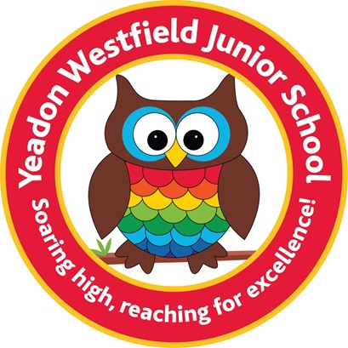

Disadvantaged Strategy Plan 2024-2025
Including the review of the previous academic year 2023-2024

This statement details our school’s use of pupil premium (and recovery premium) funding to help improve the attainment of our disadvantaged pupils.
It outlines our pupil premium strategy, how we intend to spend the funding in this academic year and the outcomes for disadvantaged pupils last academic year.
School Context.
Yeadon Westfield Junior School is a two-form entry mainstream junior school in North West Leeds. The catchment includes areas of high deprivation.
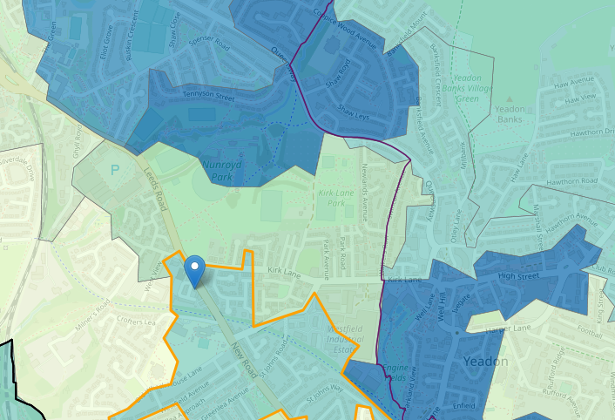
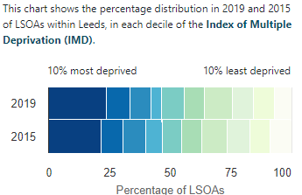

School overview
Detail | Data
Number of pupils in school | 202 (July 2024)  197 (Oct 2024)
Proportion (%) of pupil premium eligible pupils | 19.31% 39/202 (April 2024)  36/197 18.27%
Academic year/years that our current pupil premium strategy plan covers (To be carried out yearly due to reduced PAN and subsequent class organisation) | 2024-2025
Date this statement was published | October 2024
Date on which it will be reviewed | October 2026
Statement authorised by | Lisa Piotrowicz
Pupil premium lead | Caroline Scargill
Governor / Trustee lead | Helen Jones

Funding overview
Detail | Amount
Pupil premium funding allocation this academic year | £61,930.00
Recovery premium funding allocation this academic year | £0.00
Pupil premium (and recovery premium*) funding carried forward from previous years (enter £0 if not applicable) | £0.00
Total budget for this academic year | £61,930.00

Part A: Pupil premium strategy plan

Statement of intent
- Our aim is to ensure that our pupils are not disadvantaged as a result of their socioeconomic context. We believe that with the correct support all pupils can achieve their full potential, as long as the provision meets their needs. Our ultimate objectives are to:
- Remove barriers to learning created by poverty, family circumstance and background.
- Narrow the attainment gaps between disadvantaged pupils and their non-disadvantaged counterparts both within school and nationally.
- Ensure ALL pupils are able to read fluently and with good understanding to enable them to access the breadth of the curriculum.
- Develop confidence in their ability to communicate effectively in a wide range of contexts.
- Enable pupils to look after their social and emotional wellbeing and to develop resilience.
- Access a wide range of opportunities to develop their knowledge and understanding of the world. Achieving our objectives: In order to achieve our objectives and overcome identified barriers to learning we will:
Provide all teachers with high quality CPD to ensure that pupils access effective quality first teaching. This will include teachers compiling pupil profiles of Pupil Premium children to build information about each child and use this to analyse trends and inform transition. We will:
- ensure disadvantaged pupils are challenged in the work that they’re set
- act early to intervene at the point need is identified
- adopt a whole school approach in which all staff take responsibility for disadvantaged pupils’ outcomes and raise expectations of what they can achieve.
- Provide subsequent targeted intervention and support to quickly address identified gaps in learning including the use of small group work, 1:1 tuition

Challenges
This details the key challenges to achievement that we have identified among our disadvantaged pupils for the upcoming year beginning with our financial year 2024-2025.
Challenge number | Detail of challenge
1 | Writing achievement  Through staff and summative end of year assessments, writing has been identified as a key challenge, 49.41% disadvantaged children do not meet national expectations in writing. In years 6 27% and 4 37.5% disadvantaged children are not meeting national expectations in writing. (Data end July 2024)  Year 5 data shows 53.8% of disadvantaged children are not on track to meet their end of Key Stage target and 61.5% are not on track to meet age related national expectations. 75% are below A.R.E or not on track to meet national expectations in writing  69% of that cohort have a spelling age below their actual age.  Spelling  Our assessments, class and end of year summative indicate that the education of many of our disadvantaged pupils still continue to be affected by the impact of the partial school closures during the COVID-19 pandemic. Spelling continues to be a barrier to writing for many children. Basic phonic skills for our disadvantaged children are missing.  64% of children in years 4-6 are not meeting their age related spelling age. They are on average of 9.7 months behind. (Data end July 2024)
2 | Maths  A small target group of Y6 children are currently not on course/not secure to meet their end of Key Stage Target GDS target in maths. (Tested July 2024) Extra support provided for these children has accelerated progress, but need to remain in order for continued success.  Children often don’t learn their times tables at home. In the national MTC test the average score for our PPG children was 16.6 and although an increase of 5.1 from 2023 this is not in line with the national average attainment of 18.3 for disadvantaged children. Our cohort data of 17.71 also shows that we are not meeting the national average of 20.2 marks.
3 | Reading  Assessments of disadvantaged pupils show they generally have greater difficulties with phonics than their peers. This negatively impacts their development as readers. Discussions with class teachers show that many PPG children still do not complete reading at home with parents. Although results across school show good progress, more able children struggle to meet their GDS targets. 66% of year 5 children at the end of Summer 2024, who achieved GDS at KS1 are not on track to meet their end of Key Stage target.
4 | Wider Context  Social and Emotional  Our assessments, surveys, observations, safeguarding data and discussions with pupils, suggest disadvantaged children have generally more complex family circumstances, leading to the need for support. Teacher referrals for Mentor support remain consistently high. This continues to be a key focus of our Pupil Premium Plan.  Through teacher, SLT and Learning Mentor observations and discussions with pupils and families we have many identified needing social, emotional and pastoral care. Basic welfare needs remain necessary, and enrichment activities outside of school are low for these children, meaning their Cultural Capital is not as developed as their peers.  Currently 56% OF PPG children see the learning mentor.  Recently The Westfield Pantry was set up, due to the current living crisis, for families in times of need. Google form requests for food parcels are now available, along with delivery to homes if needed.  Due to current demand school uniform is also available to our children, via a discreet online ordering system to ensure every child has suitable school clothes.

Intended outcomes
This explains the outcomes we are aiming for by the end of our current 2024-2025 strategy plan, and how we will measure whether they have been achieved.
Intended outcome | Success criteria
1 a)  Writing | Children will have the skills to write confidently and fluently with a wider personal bank of language to support their work.  Target particularly the upper Y5/6 classes so that this group of children makes good progress through quality first teaching. More children achieve ARE and consequently combined results are improved. Target 40% children meeting ARE in 2024/2025
1b)  Spelling | The age related gap has narrowed, and the average age gap is reduced to one month.  Impact assessed through regular ongoing formative and summative assessment, using the graduated, assess, plan, do and review approach.
2  Maths  Improved maths attainment for disadvantaged pupils in the MTC tests. | Narrowed gap between children achieving national expectations and disadvantaged children. Children are more confident at their times tables and the average score is 20.2 or above marks in the MTC test for the general cohort and 18.3 in the disadvantaged cohort.
3  Reading  Improved reading comprehension for targeted EXS+ children | Children will read more fluently and the gap between actual age and reading age will be bridged. An independent love of reading will be developed.  The intervention will have an identifiable and valuable impact on attitude to learning. Standardised tests will provide reliable data to give teacher specific strengths and weaknesses and areas of teaching needing targeting.
4  Social and Emotional  SEMH issues are not negatively impacting on disadvantaged children’s ability to learn and progress.  Enrichment opportunities for all disadvantaged.  Learning mentor to provide key emotional and welfare support for children. | This area has a significant impact upon our pupil premium children. Consistently they require support for their SEMH. Sustained higher levels of wellbeing by the year ending 2025. To achieve and sustain improved wellbeing for all pupils in our school, particularly our disadvantaged pupils.  Enrichment is crucial for our children; we will endeavor to provide these experiences for as many children as possible to bridge the gap of the Cultural Capital. We aim to provide a significant increase in participation in enrichment activities, particularly among disadvantaged pupils. This will be done via additional opportunities such as trips, experiences within school, additional resources purchased, small group work with teachers.  Every PP child will receive further enrichment to their education.

Activity in this academic year
This details how we intend to spend our pupil premium (and recovery premium) funding this academic year to address the challenges listed above.

Teaching (for example, CPD, recruitment and retention)
Budgeted cost £3,080
Activity | Evidence that supports this approach | Challenge number(s) addressed
Thrive  Support for all staff in embedding the Thrive approach within school.  Designated staff to be given time to analyse Thrive and embed subsequent actions required. Support for class teachers to develop and embed thrive approach consistently for PP children. | Children need to have their basic SEMH needs met before they are able to thrive academically.  Broad SEMH covered with this approach.  The average impact of metacognition and self-regulation strategies is an additional seven months’ progress over the course of a year.  Metacognition and self-regulation approaches to teaching support pupils to think about their own learning more explicitly, often by teaching them specific strategies for planning, monitoring, and evaluating their learning.  Interventions are designed to give pupils a repertoire of strategies to choose from and the skills to select the most suitable strategy for a given learning tasks. | 4  £2,700
Auditing restorative actions, analysing patterns of behaviour and implementing alternative behaviour plans for individual children.  Delivering professional development for staff on behavioural strategies and de-escalation techniques. | Behaviour -Moderate impact for low cost based on extensive evidence. +4 EFF. | 4  £180
Enhancement of our maths teaching and curriculum planning in line with DfE and EEF guidance.  We will enable teacher release time to embed key elements of guidance in school and to access CPD (including Teaching for Mastery training) | The DfE non-statutory guidance has been produced in conjunction with the National Centre for Excellence in the Teaching of Mathematics, drawing on evidence-based approaches: | 2  £200

Targeted academic support (for example, tutoring, one-to-one support, structured interventions)
Budgeted cost: £34,127
Activity | Evidence that supports this approach | Challenge number(s) addressed
Writing  a) Writing Boosters  b) Ruth Miskin spelling intervention.  c) Payments to external agencies for diagnosis for specific children (when this is important for their future academic progress | a) Target PP children in year 5/6 for writing boosters.  b) Phonics approaches have a strong evidence base for indicating a positive impact on pupils, particularly from disadvantaged. Targeted phonics interventions have been shown to be more effective when delivered as regular sessions over a period up to 12 weeks. Ruth Miskin is a DFE validated systematic synthetic phonics programme. Year 3 staff to implement phonics to those children where this has not been embedded.  Nessy scheme daily to impact spelling.  Re stock new workbooks.  High impact based on low cost from extensive EFF evidence. +5 | 1  £16,000  £1,000
Maths  Booster Groups for  Times tables support for PPG for Years 3 and 4. | Booster groups before school.  Small high quality teaching and assessment including one to one and small group work. Frequent weekly access to interventions in school. Targeting of Year 3 and 4 children. Interventions recommended by the EFF as having greatest impact are delivered.  Small group support for PPG children alongside the extra targeting for the whole years cohorts. Particularly Years 5 and 6.  White Rose Maths Resources for interventions.  Moderate impact based on moderate evidence. EFF +4 | 2  £15,927  £1,200
Reading  Assembly booster. Peer tutoring.  Teachers to set up groups of children in Years 5/6 and Year 3 (PPG WTS and EXS/GDS) to share reading and read to each other during assembly times. (Or other points during the day if staff are available) | Identified children in this group with low prior attainment narrow the gap to achieve their targets, with interventions timed sensitively so that they continue to have access to the broad curriculum.  Peer Impact-High impact based on low cost from extensive EFF evidence. +5  Reading comprehension- Very high impact for very low cost based on extensive evidence. +6 | 3

Wider strategies (for example, related to attendance, behaviour, wellbeing)
Budgeted cost: £24,723
Activity | Evidence that supports this approach | Challenge number(s) addressed
Social and Emotional  Learning Mentor  - Social and emotional support 1-1 from learning mentor.  - Homework club run by RS  - Parental engagement with school. Learning mentor led.  - Attendance officer to liaise with parents.  - Art participation in the ALP art exhibition | EFF research outlines social and emotional approaches can have a positive impact on learning.  Mentoring aims to build confidence and relationships, to develop resilience and character, or raise aspirations, rather than to develop specific academic skills or knowledge.  Mentoring- Low impact moderate cost moderate evidence. EFF +2  Homework-High impact low cost from limited evidence EFF +5.  The average impact of the Parental engagement approaches is about an additional four months’ progress over the course of a year. There are also higher impacts for pupils with low prior attainment.  Embedding principles of good practice set out in the DFE’S Improving Schools Attendance advice.  EFF +3 Moderate impact for very low cost | 4  £19,523
Essential care:  - Transport to and from school.  - Parental necessities for welfare of children, petrol, clothing, times of crisis, bills etc.  - Wrap around care.  - Food Bank  (Westfield Pantry)  - Uniform provision. | It is essential that all of our children have basic care needs so they can feel safe and secure in order to progress in school. | 4  £600
Summer holiday clubs | Moderate impact for moderate cost from limited evidence. EFF +3 | 4
Music lessons and sports clubs | We wish to give all children regardless of background equal opportunities.  Low impact for low cost based upon moderate evidence. Physical activity EFF +1 | 4  £1,000
School trips and residential | It is essential that all of our children regardless of background have the same education opportunities. We offer to support parents financially for the cost of trips and other education activities outside of school. | 4  £1,000
Contingency fund for acute issues. | As per data in other schools we have identified a need to set a small amount of funding aside to respond quickly to needs that have not yet been identified. | 4  £600
Enrichment | Ensure our PPG children have access to the same cultural capital as our other pupils. Teacher to provide and also release for teachers to carry out this area, | 4  £2,000

Total budgeted cost: £61,930

Part B: Review of the previous academic year 2023-2024

Outcomes for disadvantaged pupils
We have analysed the performance of our school’s disadvantaged pupils during the previous academic year, drawing on national assessment data and our own internal summative and formative assessments.
Our evaluation of the approaches delivered last academic year indicates that the strategy of frequent intervention booster groups targeting PPG children in reading has been particularly effective. 80% of children attending the reading group met or exceeded their end of year target based upon KS1 data.
Year 4 combined result 69%, Year 4 PP combined 75%
Year 5 combined 57% Year 5 PPG 38% an increase of13%
10% of PP achieved GDS in reading. 73% PP ARE in reading.
27% children achieved ARE in writing. 0% GDS.
In the national MTC test the average score for our PPG children was 16.6 and although an increase of 5.1 from 2023 this is not in line with the national average attainment of 18.3 for disadvantaged children. This will continue to be a target for 2024/2025.
Year 3
Reading:  Below EXS: 25%  At and above EXS: 75%  Above EXS: 12.5% | Writing:  Below EXS: 37.5%  At and above EXS: 62.5%:  Above EXS: 12.5% | Maths:  Below EXS: 37.5%  At and above EXS: 62.5%  Above EXS: 25.0%

Year 4
Reading:  Below EXS: 0%  At and above EXS: 100%  Above EXS: 40% | Writing:  Below EXS: 20%  At and above EXS: 80%  Above EXS: 20% | Maths:  Below EXS: 20%  At and above EXS: 80%  Above EXS: 40%

Year 5
Reading:  Below EXS: 38.5%  At and above EXS: 61.5%  Above EXS: 15.4% | Writing:  Below EXS: 61.5%  At and above EXS: 38.5%  Above EXS: 0% | Maths:  Below EXS: 38.5%  At and above EXS: 61.5%  Above EXS: 7.7%

Year 6
Reading:  Below EXS: 27.3%  At and above EXS: 72.7%  Above EXS: 0% | Writing:  Below EXS:81.8%  At and above EXS: 18.2%  Above EXS: 0% | Maths:  Below EXS: 45.5%  At and above EXS: 54.5%  Above EXS: 0%

