Yeadon Westfield Junior School



Disadvantaged Strategy Plan 2023-2024

This statement details our school’s use of pupil premium (and recovery premium) funding to help improve the attainment of our disadvantaged pupils.
It outlines our pupil premium strategy, how we intend to spend the funding in this academic year and the outcomes for disadvantaged pupils last academic year.
School Context.
Yeadon Westfield Junior School is a two-form entry mainstream junior school in North West Leeds. The catchment includes areas of high deprivation.
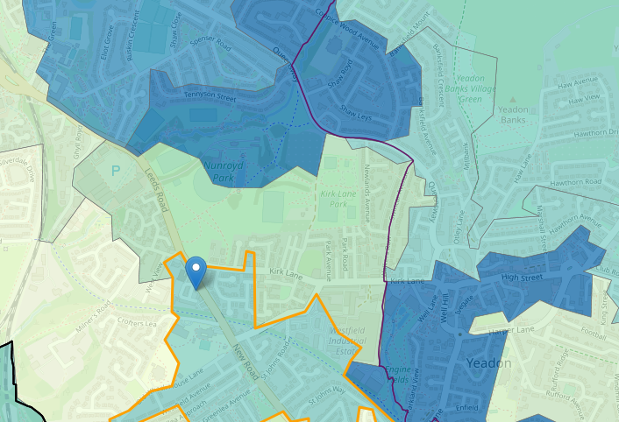
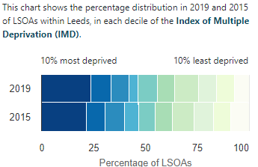

School overview
Detail | Data
Number of pupils in school | 200
Proportion (%) of pupil premium eligible pupils | 39/202 19%
Academic year/years that our current pupil premium strategy plan covers (3 year plans are recommended) | 2023-2024
Date this statement was published | September 2023
Date on which it will be reviewed | July 2026
Statement authorised by | Lisa Piotrowicz
Pupil premium lead | Caroline Scargill
Governor / Trustee lead | Helen Jones

Funding overview
Detail | Amount
Pupil premium funding allocation this academic year | £81,860
Recovery premium funding allocation this academic year | £0.00
Pupil premium (and recovery premium*) funding carried forward from previous years (enter £0 if not applicable) | £0.00
Total budget for this academic year | £81,860

Part A: Pupil premium strategy plan

Statement of intent
- Our aim is to ensure that our pupils are not disadvantaged as a result of their socioeconomic context. We believe that with the correct support all pupils can achieve their full potential, as long as the provision meets their needs. Our ultimate objectives are to:
- Remove barriers to learning created by poverty, family circumstance and background.
- Narrow the attainment gaps between disadvantaged pupils and their non-disadvantaged counterparts both within school and nationally.
- Ensure ALL pupils are able to read fluently and with good understanding to enable them to access the breadth of the curriculum.
- Develop confidence in their ability to communicate effectively in a wide range of contexts.
- Enable pupils to look after their social and emotional wellbeing and to develop resilience.
- Access a wide range of opportunities to develop their knowledge and understanding of the world. Achieving our objectives: In order to achieve our objectives and overcome identified barriers to learning we will:
- Provide all teachers with high quality CPD to ensure that pupils access effective quality first teaching. This will include teachers compiling pupil profiles of Pupil Premium children to build information about each child and use this to analyse trends and inform transition.
- Provide targeted intervention and support to quickly address identified gaps in learning including the use of small group work, 1:1 tuition

Challenges
This details the key challenges to achievement that we have identified among our disadvantaged pupils for the upcoming academic year 2023-2024.
Challenge number | Detail of challenge
1 | Writing achievement  Through staff and summative end of year assessments, writing has been identified as a key challenge, 55% disadvantaged children do not meet national expectations in writing. Year 5 63% and Year 4 69% disadvantaged children are not meeting national expectations in writing.  Many children are choosing to spend more time at home on devices and less time talking and reading. This has resulted in significant knowledge gaps leading to pupils falling further behind age-related expectations, especially in writing. Observations, and discussions with pupils indicate underdeveloped oral language skills and vocabulary gaps among many disadvantaged pupils. Handwriting has also been observed as a barrier to a significant amount of our disadvantaged children.  Combined end of year data, showed 12% children met ARE. 73% children were either below ARE/below their end of year target. Writing in particular feeds into this data as 58% of the PPG children were either below their end of year target or below ARE. One Year 5 class has 100% disadvantaged children working at WTS for writing.
2 | Spelling  Our assessments, class and end of year summative indicate that the education and wellbeing of many of our disadvantaged pupils continues to be affected by the impact of the partial school closures during the COVID-19 pandemic. Spelling continues to be a barrier to writing for many children. Basic phonic skills are missing and disadvantaged children are not working.  Disadvantaged children, although making good progress, in one Year 4 class on average are 6 months behind their actual age for spelling. In one year 5 class PPG children’s spelling ages are on average 6.7 months their actual ages. The average child is 2.1 months behind their actual age.
3 | Maths  Internal and external assessments indicate that maths attainment among disadvantaged pupils is significantly below that of non-disadvantaged pupils. 34% disadvantaged children are not meeting age related expectations, including 40% of year 3 children. This gap remains steady to the end of KS2.  Children often don’t learn their times tables at home. In the national MTC test the average score for the PPG children was 11/25. 3 children were unable to access the test and were not entered.
4 | Reading  Assessments of disadvantaged pupils show they generally have greater difficulties with phonics than their peers. This negatively impacts their development as readers. Discussions with class teachers show that many PPG children do not complete reading at home with parents.  41% children are not meeting their end of year targets, 34% are below ARE.
5 | Wider Context  Social and Emotional  Assessments, observations, safeguarding data and discussions with pupils, suggest disadvantaged children have generally more complex family circumstances, leading to the need for support. Teacher referrals for Mentor support remain high. 30% children recorded as pupil premium are also involved with social care or other external agencies Coupled with this 35% of our disadvantaged children are also on the SEN register.  Through teacher, SLT and Learning Mentor observations and discussions with pupils and families we have many identified needing social, emotional and pastoral care. Currently 29/39 children see the learning mentor. This has increased since last academic year.  Basic welfare needs have increased, and enrichment activities outside of school are low for these children, meaning their Cultural Capital is not as developed as their peers.

Intended outcomes
This explains the outcomes we are aiming for by the end of our current 2023-2024 strategy plan, and how we will measure whether they have been achieved.
Intended outcome | Success criteria
1 Writing  Oracy  Aim to support pupils to articulate key ideas, consolidate understanding and extend vocabulary. | Children will have the skills to write confidently and fluently with a wider personal bank of language to support their work.  This group of children makes good progress through quality first teaching. More children achieve ARE and consequently combined results are improved. Target 55% children meeting ARE
2 Spelling | The age related gap has narrowed, and the average age gap is reduced to one month.  Impact assessed through regular ongoing formative and summative assessment, using the graduated, assess, plan, do and review approach.
3 Maths  Improved maths attainment for disadvantaged pupils in the MTC tests. | Narrowed gap between children achieving national expectations and disadvantaged children. Children are more confident at their times tables average score is 12 or above marks in the MTC test.
4 Reading  Improved reading comprehension amongst disadvantaged children. | Children will read more fluently and the gap between actual age and reading age will be bridged. An independent love of reading will be developed.  The intervention will have an identifiable and valuable impact on attitude to learning. Standardised tests will provide reliable data to give teacher specific strengths and weaknesses and areas of teaching needing targeting.  50% children to meet their end of year target.
5 Social and Emotional  SEMH issues are not negatively impacting on disadvantaged children’s ability to learn and progress.  Enrichment opportunities for all disadvantaged.  Learning mentor to provide key emotional and welfare support for children. | Sustained higher levels of wellbeing by 2024/25. To achieve and sustain improved wellbeing for all pupils in our school, particularly our disadvantaged pupils.  Enrichment is crucial for our children, we will endeavour to provide these experiences for as many children as possible to bridge the gap of the Cultural Capital.

Activity in this academic year
This details how we intend to spend our pupil premium (and recovery premium) funding this academic year to address the challenges listed above.

Teaching (for example, CPD, recruitment and retention)
Budgeted cost £4,500
Activity | Evidence that supports this approach | Challenge number(s) addressed
- Writing Oracy  Training for staff.  Relaunch oracy model writing | Evidence suggests oral language interventions, such as high-quality classroom teaching and discussion, are inexpensive to implement with high impacts on reading:  Education Endowment Foundation evidence this can advance learning by +6. Very high impact for low cost.  Teachers will be asked to focus on and track closely the progress of their disadvantaged children. Same day and next day interventions will be encouraged, with disadvantaged, including high attainers, receiving this. | 2  4,500

Targeted academic support (for example, tutoring, one-to-one support, structured interventions)
Budgeted cost: £42,500
Activity | Evidence that supports this approach | Challenge number(s) addressed
GAPS  Ruth Miskin spelling intervention. | Phonics approaches have a strong evidence base for indicating a positive impact on pupils, particularly from disadvantaged. Targeted phonics interventions have been shown to be more effective when delivered as regular sessions over a period up to 12 weeks. Ruth Miskin is a DfE validated systematic synthetic phonics programme.  High impact based on low cost from extensive EFF evidence. +5 | 2  9,000
Maths  Booster Groups  Times tables support for PPG for Year 4 | High quality teaching and assessment including one to one and small group is the effective. Frequent weekly access to interventions in school. Targeting of Year 3 and 4 children. Interventions recommended by the EFF as having greatest impact are delivered.  Moderate impact based on moderate evidence. EFF +4 | 3  17.750
Reading  Assembly booster. Peer tutoring.  Teachers to set up groups of children in Years 5/6 and Year 3/4 (PPG WTS and EXS/GDS) to share reading and read to each other during assembly times. Children who are the mentors (ideally GDS/EXS) from the year above who are competent in WRAP techniques to support reading comprehension strategies. Working 1-1 with their peers. | Identified children in this group with low prior attainment narrow the gap to achieve their targets, with interventions timed sensitively so that they continue to have access to the broad curriculum.  Peer impact-High impact based on low cost from extensive EFF evidence. +5  Reading comprehension- Very high impact for very low cost based on extensive evidence. +6 | 4  15,750

Wider strategies (for example, related to attendance, behaviour, wellbeing)
Budgeted cost: £34,860
Activity | Evidence that supports this approach | Challenge number(s) addressed
Social and Emotional  Learning Mentor  - Social and emotional support 1-1 from learning mentor.  - Behaviour interventions organised by LM when needed.  - Homework club run by LM  - Parental engagement with school. Learning mentor led.  - Attendance officer to liaise with parents. | EFF research outlines social and emotional approaches can have a positive impact on learning  Mentoring- Low impact moderate cost moderate evidence. EFF +2  Behaviour -Moderate impact for low cost based on extensive evidence. +4 EFF.  Homework-High impact low cost from limited evidence EFF +5.  Moderate impact low cost from extensive evidence. EFF +4  Embedding principles of good practice set out in the DFE’S Improving Schools Attendance advice. | 5  18,900
Essential care:  - Taxis to and from the trust.  - Taxis to and from school.  - Parental necessities for welfare of children, food shops, petrol, clothing, times of crisis, bills etc.  - Wrap around care. | It is essential that all of our children have basis care needs so they can feel safe and secure in order to progress in school. | 5  £1,400  £1,000  £1,000  800
Summer holiday clubs | Moderate impact for moderate cost from limited evidence. EFF +3 | 5  2,000
Music lessons and sports clubs | We wish to give all children regardless of background equal opportunities.  Low impact for low cost based upon moderate evidence. Physical activity EFF +1 | 5  8,260
School trips and residential | It is essential that all of our children regardless of background have the same education opportunities. We offer to support parents financially for the cost of trips and other education activities outside of school. | 5  1,500

Total budgeted cost: £81,860

Part B: Review of the previous academic year. (Juniper report available in October).

Outcomes for disadvantaged pupils
This data is taken from our internal assessments based on PUMA, PIRA and GaPs standardised tests, previous KS2 SAT papers and teacher assessments against writing grids based on the end of KS2 writing framework.
This is taken from a Juniper Report produced by O’track which is our data system. Our school data is in green, the LA’s is in blue and the Juniper benchmark is in purple (the data is compared to other schools who have used the Juniper Education’s tracking systems, which is c. 6000 schools).
Year 3 Year 4 Year 5 Year 6
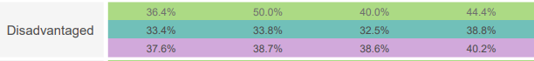
Reading data 2021-2022
Year 3 Year 4 Year 5 Year 6
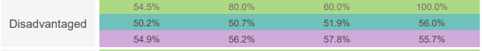

Writing Data 2021-2022

Maths Data 2021-2022
Year 3 Year 4 Year 5 Year 6
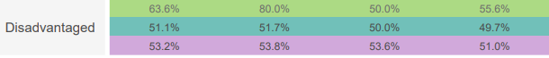
Combined Data 2021-2022
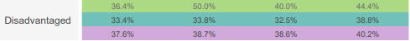
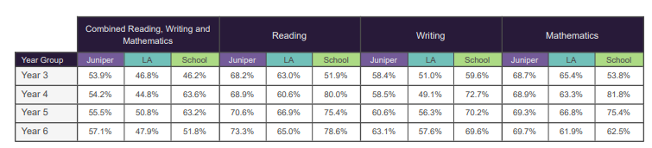

Progress 2022-2023
Pupil Premium end of key stage data
Percentage of Pupil Premium children who met or exceeded their end of key stage target
Reading | 80.0%
Writing | 62.5%
Maths | 12.5%

End of Key Stage Data
Percentage of children working at and above EXS
Year 6 | Cohort | PP
Reading | 80.0% | 77.0%
Writing | 69.1% | 46.2%
Maths | 65.5% | 46.2%
Combined RWM | 52.7% | 38.5%

Percentage of children working at and above EXS
Year 3 | Cohort | PP
Reading | 95.0% | 80.0%
Writing | 72.5% | 60.0%
Maths | 87.5% | 60.0%
Combined RWM | 70% | 60.0%

Percentage of children working at and above EXS
Year 4 | Cohort | PP
Reading | 84.9% | 69.2%
Writing | 54.7% | 30.8%
Maths | 86.8% | 69.2%
Combined RWM | 54.7% | 30.8%

Percentage of children working at and above EXS
Year 5 | Cohort | PP
Reading | 82.1% | 36.4%
Writing | 76.8% | 36.4%
Maths | 92.9% | 81.8%
Combined RWM | 73.2% | 23.7%

