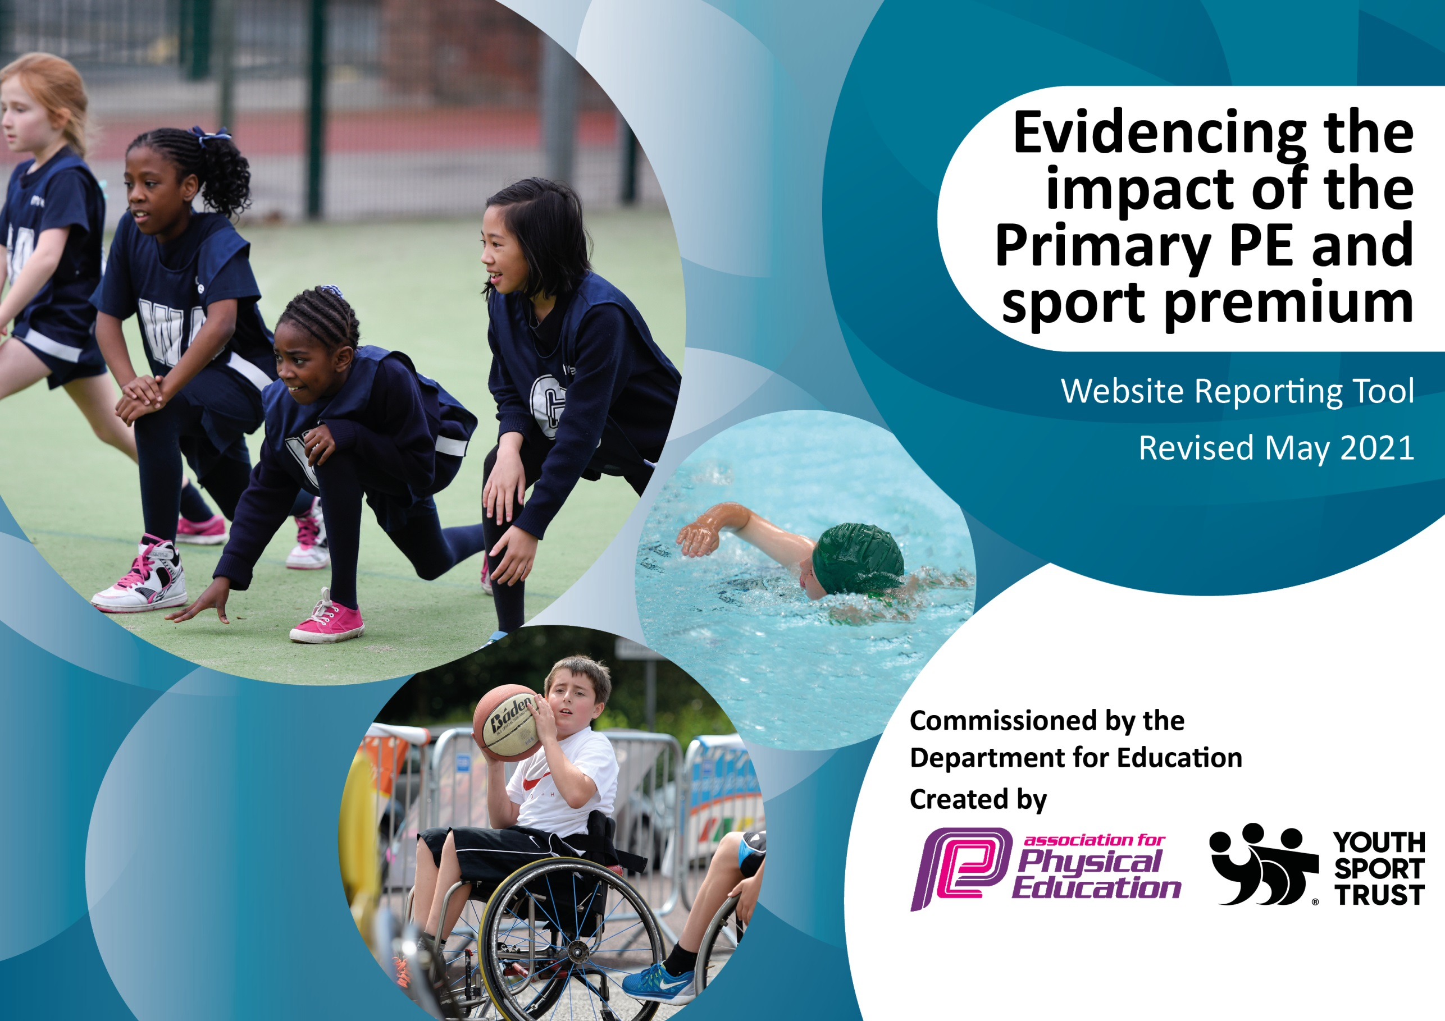

It is important that your grant is used effectively and based on school need. The Education Inspection Framework (Ofsted 2019 p64) makes clear there will be a focus on ‘whether leaders and those responsible for governors all understand their respective roles and perform these in a way that enhances the effectiveness of the school’.

Under the Quality of Education criteria (p41) inspectors consider the extent to which schools can articulate their curriculum (INTENT), construct their curriculum (IMPLEMENTATION) and demonstrate the outcomes which result (IMPACT).

To assist schools with common transferable language this template has been developed to utilise the same three headings which should make your plans easily transferable between working documents.

Schools must use the funding to make additional and sustainable improvements to the quality of Physical Education, School Sport and Physical Activity (PESSPA) they offer. This means that you should use the Primary PE and sport premium to:

- Develop or add to the PESSPA activities that your school already offer
- Build capacity and capability within the school to ensure that improvements made now will benefit pupils joining the school in future years
- The Primary PE and sport premium should not be used to fund capital spend projects; the school’s budget should fund these.
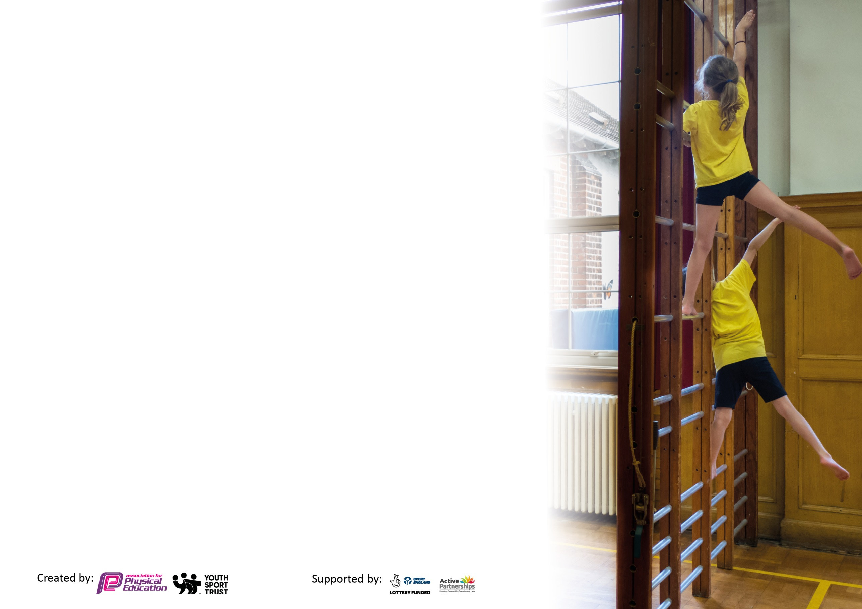
Please visit gov.uk for the revised DfE guidance including the 5 key indicators across which schools should demonstrate an improvement. This document will help you to review your provision and to report your spend. DfE encourages schools to use this template as an effective way of meeting the reporting requirements of the Primary PE and sport premium.

We recommend you start by reflecting on the impact of current provision and reviewing the previous spend.

Schools are required to publish details of how they spend this funding, including any under-spend from 2019/2020, as well as on the impact it has on pupils’ PE and sport participation and attainment by the end of the summer term or by 31st July 2021 at the latest.

We recommend regularly updating the table and publishing it on your website throughout the year. This evidences your ongoing self-evaluation of how you are using the funding to secure maximum, sustainable impact. Final copy must be posted on your website by the end of the academic year and no later than the 31st July 2021. To see an example of how to complete the table please click HERE.



Please note: Although there has been considerable disruption in 2020 it is important that you publish details on your website of how you spend the funding - this is a legal requirement.
Support for review and reflection - considering the 5 key indicators from DfE, what development needs are a priority for your setting and your pupils now and why? Use the space below to reflect on previous spend and key achievements and areas for development.

N.B. In this section you should refer to any adjustments you might have made due to Covid-19 and how these will influence further improvement.
Key achievements to date until July 2020: | Areas for further improvement and baseline evidence of need:
- New PE planning and assessment tool (GetSet4PE) implemented successfully  - PE audit including Pupil and Staff Questionnaires completed  - New swimming, gymnastics, badminton and playground equipment purchased 27/11/20  - New athletics, dodgeball and skipping equipment purchased 12/02/21  - New athletic and rounders purchased on 13/05/21  - Staff trained on games and activities to make the best use of the new playground markings  - Children participated in Level 0 competitions: Skip Into Summer, fitness personal best challenges, Brownlee Medal Challenge, home learning challenges and Daily Mile  - Level 1 competitions within school included Sports Day, inter-class football and penalty shoot-outs and games/competitions within PE lessons  - 1:1 sports interventions from Guiseley Community Foundation | - Identify most inactive pupils and provide opportunities to encourage them to participate in extra-curricular physical activities  - Intra-school competition to resume Covid-permitting, aiming for 80% of children participating in competition  - Further staff training to explore benefits of GetSet4PE  - CPD to boost staff confidence (e.g. NCTP Teacher of Primary Swimming course)

Did you carry forward an underspend from 2019-20 academic year into the current academic year? YES
Total amount carried forward from 2019/2020 £ 1,500
+ Total amount for this academic year 2020/2021 £ 18,280
= Total to be spent by 31st July 2021 £ 19,780

Meeting national curriculum requirements for swimming and water safety.

N.B Complete this section to your best ability. For example you might have practised safe self-rescue techniques on dry land which you can transfer to the pool when school swimming restarts.
Due to exceptional circumstances priority should be given to ensuring that pupils can perform safe self rescue even
if they do not fully meet the first two requirements of the NC programme of study.
What percentage of your current Year 6 cohort swim competently, confidently and proficiently over a distance of at least 25 metres?  N.B. Even though your pupils may swim in another year please report on their attainment on leaving primary school at the end of the summer term 2021.  Please see note above. | 95%
What percentage of your current Year 6 cohort use a range of strokes effectively [for example, front crawl, backstroke and breaststroke]?  Please see note above. | 90%
What percentage of your current Year 6 cohort perform safe self-rescue in different water-based situations? | 90%
Schools can choose to use the Primary PE and sport premium to provide additional provision for swimming but this must be for activity over and above the national curriculum requirements. Have you used it in this way? | No, but we have signed up for free intensive swimming lessons

Action Plan and Budget Tracking
Capture your intended annual spend against the 5 key indicators. Clarify the success criteria and evidence of impact that you intend to measure to evaluate for pupils today and for the future.

Academic Year: 2020/21 | Total fund allocated: £ | Date Updated:
Key indicator 1: The engagement of all pupils in regular physical activity – Chief Medical Officers guidelines recommend that primary school pupils undertake at least 30 minutes of physical activity a day in school |  |  |  | Percentage of total allocation:
 |  |  |  | 38%
Intent | Implementation |  | Impact
Your school focus should be clear what you want the pupils to know and be able to do and about  what they need to learn and to  consolidate through practice: | Make sure your actions to achieve are linked to your intentions: | Funding allocated: | Evidence of impact: what do pupils now know and what can they now do? What has changed?: | Sustainability and suggested next steps:
- Increased dinner time and break time activities for all children. | - Employ two Soccer 5’s coaches to deliver lunch time sports.  - Guiseley Community Foundation have coached Play Time Leaders to organise their own games with their class at playtime.  - Skip Into Summer - a month of skills being taught and skipping being promoted | £4,750  S A Soccer 5’s | - Structed games are set up by Soccer 5’s each lunchtime  - All children have been taught games using playground markings after playground marking training on 23/04/21. | - Trained Playtime Leaders to organise activities more frequently  - Sports Reps to monitor activity levels of their class and feedback during Sports Rep meetings.  - Pupil audit suggests more team games are wanted by children e.g. rounders and basketball as well as independent games, e.g. beanbag throwing
- Physical interventions during the school day to least active children. | - Sports coaches employed are deliver weekly 1:1 PE sessions for children who lack confidence. Sports coaches also deliver group intervention for children identified as least active.  - Physical Activity assemblies from Donna Russel delivered on Y5-6 on Friday 14th May and Y3-4 on Thursday 15th July to raise the profile of physical activity and its benefits. | Twice a week  £40 x 38 = £1,520  Guiseley Community Foundation  £1,200  Active Schools Service Level Agreement | - Guiseley Community Foundation working 1:1 with children lacking confidence. Teachers to report on difference to P.E coordinator before looking at different children.  - Photographs to go on in P.E folder and on website of group intervention run by sports coaches.  - Children are now more able to explain the importance of the physical, mental and social benefits of Physical Activity. | - Questionnaire teachers to gain a new list of children who don’t engage in physical activity to set up further provision next year.  - Create a Physical Activity policy with the help of Donna Russel and SA+
- Embedding physical activity into the school day | - Encourage walking, cycling and scooting to and from school using the WOW Travel Tracker  - Some year groups have implemented daily/active mile |  | - These help to develop a lifelong habit of daily physical activity | - Further promotion of Physical activity, brain break activities (e.g. Go Noodle) to boost productivity, behaviour etc.
Key indicator 2: The profile of PESSPA being raised across the school as a tool for whole school improvement |  |  |  | Percentage of total allocation:
 |  |  |  | 1%
Intent | Implementation |  | Impact
Your school focus should be clear what you want the pupils to know and be able to do and about  what they need to learn and to  consolidate through practice: | Make sure your actions to achieve are linked to your intentions: | Funding allocated: | Evidence of impact: what do pupils now know and what can they now do? What has changed?: | Sustainability and suggested next steps:
- Ensure parents, children, teachers, governors and visitors are aware of what PE and sport is taking place throughout school. | - Update school website and P.E display board with pictures. |  | Pupils are aware of the breadth of sports taught in PE via Curriculum map on PE page of website | - Add sports fixtures/results on newsletter when appropriate  - Active Leeds timetable on school P.E display once published.  - Display needed on playground so that parents can see it on a regular basis  - Resume celebration assemblies for sporting achievements both in and out of school when appropriate
- Raise the profile of P.E throughout school, embedding sport within the curriculum. | - Physical Activity assemblies  - Staff PE polo shirts | £224 | Link with the school development plan or plans to improve the outdoor use in lessons. | - Develop a list of G & T / HA writers that can be used as sports reporters at events.
- Participate in Schools Games events | - Run intra-school competitions (maybe just Year group classes for now) to aid the School Games Mark application. | Signed up for Active Schools calendar  (see KI 1) | Children took part in:  - Skip Into Summer project, fitness personal best challenges, Brownlee Medal Challenge, home learning challenges and Daily Mile  - Sports Day, inter-class football and penalty shoot-outs and games/competitions within PE lessons | - Sign up to as many events as possible once sports calendar back up and running to earn School Games Mark  - Enter the events and update the website with pictures.  - Enter a wider range of sports - Use sports coaches to do taster sessions so children are up to speed with the rules before they compete.

Key indicator 3: Increased confidence, knowledge and skills of all staff in teaching PE and sport |  |  |  | Percentage of total allocation:
 |  |  |  | 5%
Intent | Implementation |  | Impact
Your school focus should be clear | Make sure your actions to | Funding | Evidence of impact: what do | Sustainability and suggested
what you want the pupils to know | achieve are linked to your | allocated: | pupils now know and what | next steps:
and be able to do and about | intentions: |  | can they now do? What has
what they need to learn and to |  |  | changed?:
consolidate through practice:
- Increase the quality of PE sessions delivered in school. | - Monitor lessons and planning to discover any staff areas of development. |  | Audit and monitoring due, areas of development need to be addressed.  Targets to be set. | - Staff training on all GetSet4PE features  - Use staff questionnaire to analyse staff’s perceived strengths and areas for development.
- Offer all teachers and support staff opportunities for CPD. | - From monitoring identify areas of development for staff and find suitable courses (e.g. e-learning). | £1000 | Staff questionnaires identify further CPD requirements. | - Continue to offer staff support in areas they lack confidence  - Continue to seek out CPD for all staff.  Use staff questionnaire to analyse staff’s perceived strengths and areas for development.
Key indicator 4: Broader experience of a range of sports and activities offered to all pupils |  |  |  | Percentage of total allocation:
 |  |  |  | 55%
Intent | Implementation |  | Impact
Your school focus should be clear | Make sure your actions to | Funding | Evidence of impact: what do | Sustainability and suggested
what you want the pupils to know | achieve are linked to your | allocated: | pupils now know and what | next steps:
and be able to do and about | intentions: |  | can they now do? What has
what they need to learn and to |  |  | changed?:
consolidate through practice:
- Increase the range of sports taught within PE lessons. | - Continue to use links with specialist coaches:  karate  orienteering  Velocity | £90 x 38 weeks = £3,420  £75 x 12 weeks = £900  £60 x 38 weeks £2,280  Total = £6,600 | Karate and orienteering now written into the curriculum.  Velocity have been notified of updated curriculum map.  Wider range of sports now being taught – see updated Curriculum map. | - Meet with Velocity coaches to update the school curriculum map with any opportunities they may offer.  - Liaise with Karate instructor to continue provision, but cease work with orienteering coach as teachers can teach OAA through GetSet4PE plans.
- Ensure dinner activities are varied. | - External providers- Soccer 5s to deliver a different sport each day and rotate the sports on a half termly basis. These sports to be determined by questionnaires completed by the School Sports Council. | As per above  (see KI 1) | Pictures children participating in dinner time sports and reward play time activities needed on website. | - Meet with Soccer 5’s provision for next year.  - Train children and staff to lead these sessions to make the provision internal.  Next Steps  Working with the sports council develop a questionnaire to find what sports children would like to be included in the P.E curriculum. Also, develop an electronic log so further analysis of participation can be done.
- Improve the range of sports offered as extra-curricular activities. | - Football club? Archery club? Multi Skills? | £450 | To resume in new year. | - Liaise with external providers to continue current provision.  - Enquired about badminton coaching through Badminton England – reach out again in Sept.  - Encourage staff to run extra- curricular clubs.  Working with the sports council develop a questionnaire to find what sports children would like to be offered as extra-curricular activities.  Learning Support Assistant to support football club?  Guiseley will have a wider range of specialist coaches next year.
- Resume after-school clubs when safe to do so, offering priority for pupil premium children | - Pupil premium children given priority places | £500 | To resume in new year. | Meet with external providers to continue current provision.  Encourage PPG children to take part again.  Filter questionnaire to pupil premium children. Are there any opportunities they would prefer?
- Promote outdoor and adventurous activities. | - Orienteering instructor to teach Y3 and Y5  - Velocity coaches and teaching staff OAA as per updated Curriculum map  - More OAA opportunities at residential  - Compasses and maps purchased | (See KI 4)  £54 | Improved map-reading and teamwork skills. | - Outdoor adventure activities booked for September through West Leeds Activity Centre for 24 PPG children
- Ensure sports equipment is available for all sports. | - Regular checks made of the current equipment. Equipment replenished when needed in accordance with new curriculum map. | £150 for swimming  £1400 gymnastics  £750 badminton  £200 football  £725 athletics  £125 rounders  Total = £3,350 | New equipment purchased:  Goggles, woggles, caps & discs for swimming  Badminton posts, nets, rackets etc.  Athletics hurdles, throwing equipment, tape measures, long jump mats etc.  Audited all equipment Nov 2020.  All children able to receive high quality PE lessons using the correct equipment which is all in working order. | - All equipment to be kept in good order in the correct place.  - Staff questionnaire to identify other areas which need investment.

Key indicator 5: Increased participation in competitive sport |  |  |  | Percentage of total allocation:
 |  |  |  | 1%
Intent | Implementation |  | Impact
Your school focus should be clear | Make sure your actions to | Funding | Evidence of impact: what do | Sustainability and suggested
what you want the pupils to know | achieve are linked to your | allocated: | pupils now know and what | next steps:
and be able to do and about | intentions: |  | can they now do? What has
what they need to learn and to |  |  | changed?:
consolidate through practice:
Develop the competition programme to include a wider range of competitions and activities for all year groups that appeal to and meet the needs of all pupils formulated through consultation with pupils. This will include personal best, intra-school and inter-school competitions | - Register of children who are attending events to be kept. Ensure that a range of children are given the opportunity to attend.  - Buy sports day equipment, stickers, medals and trophies for football, cross country and sports day | £250 | Amount of children taking part in extra curricular sport has not increased due to Covid but are due to increase in the new school year.  Positive attitude and engagement of all children in PE lessons | Renewed subscription for SLA with Active schools (see KI 1). Events to resume in new year.  Sign up to as many events as possible.  Can we get back up to the 80% of children attending at least one event in 2018-19?

Signed off by
Head Teacher:
Date:
Subject Leader: | Matthew Otto-Davis
Date: | 22/07/21
Governor: | Steve Taylor
Date: | 22/07/21

