
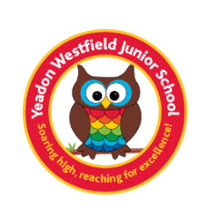
Year 3 Book List
We know that as parents, you love to read to your children and for them to read to you so we have created a book list that has lots of exciting, new books that your child will love to read as well as books that tie in with the topics they will be studying across the year at school. Each half term, the children will read a main topic book in class that links to their writing work and the topic (this is indicated in blue below). You are more than welcome to read this book with your child but it is one that will be read and studied in class as well.
Autumn 1 | Autumn 2 | Spring 1 | Spring 2 | Summer 1 | Summer 2
Ancient Egypt |  | Stone Age to Iron Age | Volcanoes | The United Kingdom | Eco-Schools  Healthy living  School grounds project
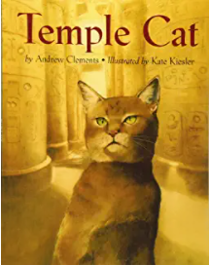  Temple Cat  by Andrew Clements and Kate Kiesler |  | 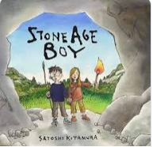  Stone Age Boy by Satoshi Kitamura | 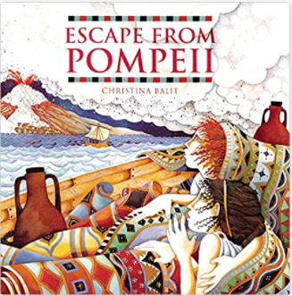  Escape from Pompeii by Christina Balit | 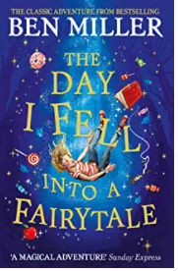  The day I fell into a Fairytale by Ben Miller | 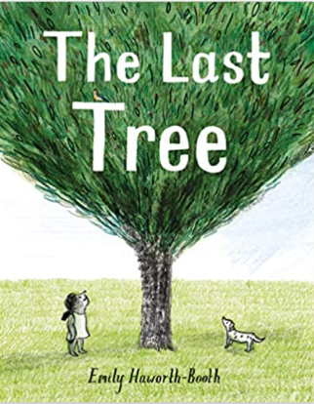  The Last Tree by Emily Haworth-Booth
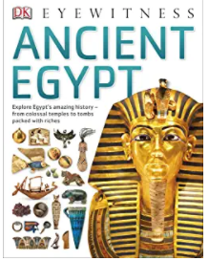    Everything: Ancient Egypt National Geographic Kids  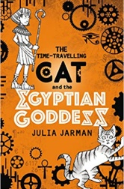  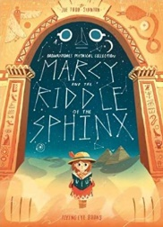  Ancient Egypt DK Eyewitness  Marcy and the Riddle of the Sphinx by Joe Todd Stanton  The Time-Travelling Cat and the Egyptian Goddess by Julia Jarma  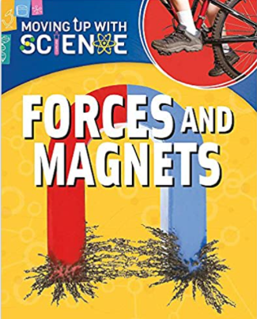  Magnet Max by Monica Lozano Hughes  Forces and Magnets: Moving up with Science |  | 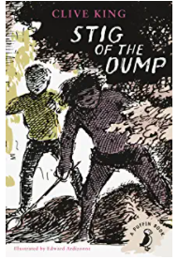  Stig of the dump  by Clive King  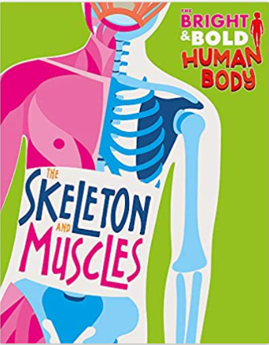  Skeletons and Muscles  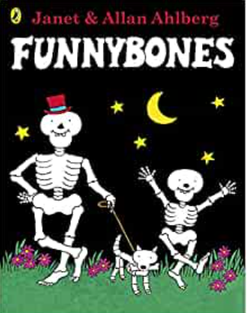  Funny Bones by Janet and Allan Ahlberg | 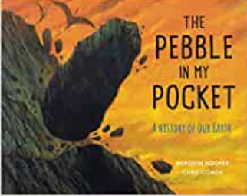  The Pebble in my pocket: A history of our Earth by Meredith Hooper  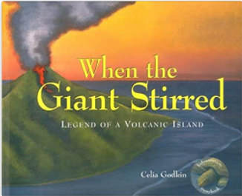  When the Giant stirred by Celia Godkin  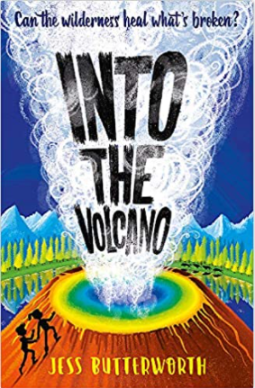  Into the Volcano by Jess Butterworth | 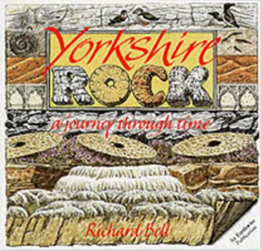  Yorkshire Rock: A Journey Through Time – Earthwise Popular Science Books    Children’s History of Yorkshire  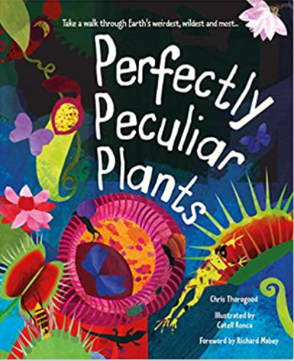  Perfectly Peculiar Plants    The Extraordinary Gardener by Sam Broughton | 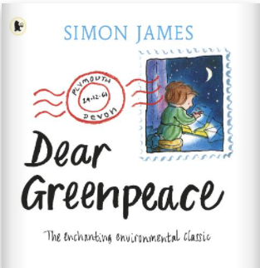  Dear Greenpeace by Simon James  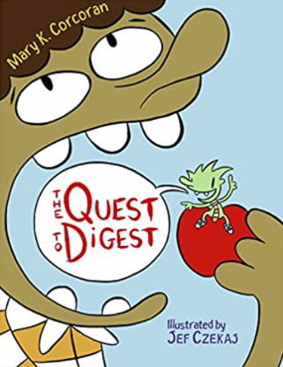  The Quest to Digest  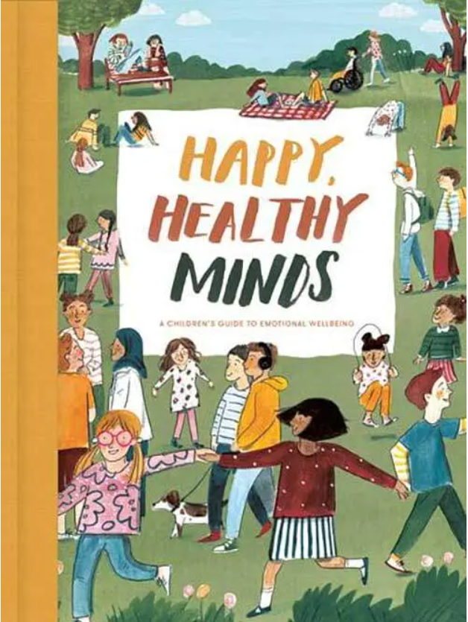  Happy, Healthy Minds: The School of Life
Bedtime Box: your child will bring home the classes Bedtime Box during the course of the year and will read one or more of the following classic stories:
Alice in Wonderland, The Wizard of Oz, Peter Pan and Black Beauty.

