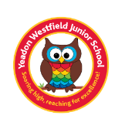
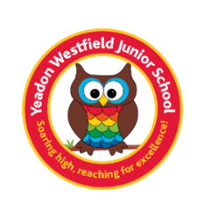
Year 4 Book List
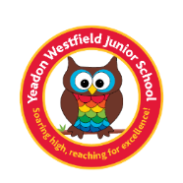
We know that as parents, you love to read to your children and for them to read to you so we have created a book list that has lots of exciting, new books that your child will love to read as well as books that tie in with the topics they will be studying across the year at school. Each half term, the children will read a main topic book in class that links to their writing work and the topic (this is indicated in blue below). You are more than welcome to read this book with your child but it is one that will be read and studied in class as well.
Autumn 1 | Autumn 2 | Spring 1 | Spring 2 | Summer 1 | Summer 2
The Romans |  | The Maya | Mountains | Rivers and Coasts | Eco-Schools  Waste and  School grounds project
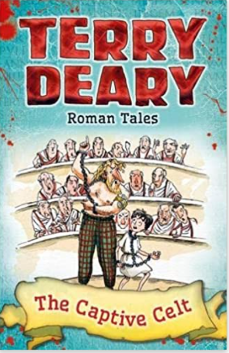  The Captive Celt – Terry Deary  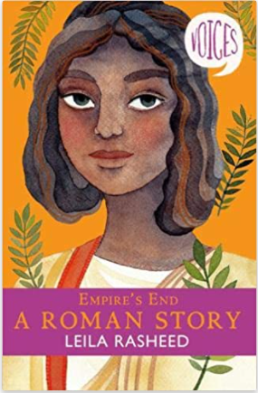  Empire’s End: A Roman Story |  | 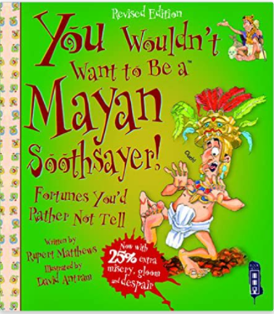  You wouldn’t want to be a Mayan Soothsayer! By Rupert Matthews  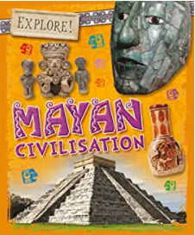  Explore! Mayan Civilisation by Ozzi Howell | 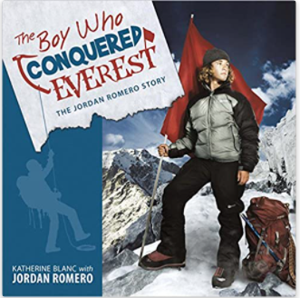  The Boy who conquered Everest: The Jordan Romero story. | 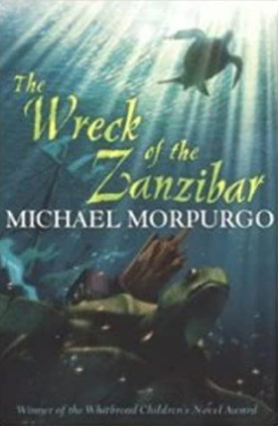  The Wreck of the Zanzibar by Michael Morpurgo | 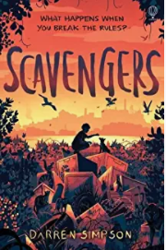  Scavengers by Darren Simpson
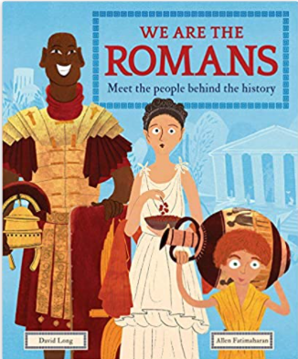  We are the Romans: Meet the people behind the history by David Long  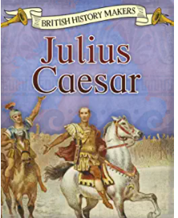  Julius Caesar by Claire Thorpe |  | 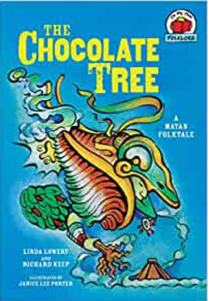  The Chocolate Tree by Linda Lowery  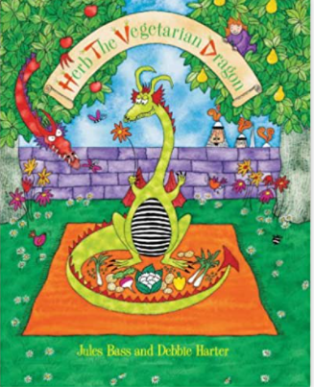  Herb the vegetarian dragon by Jules Bass | 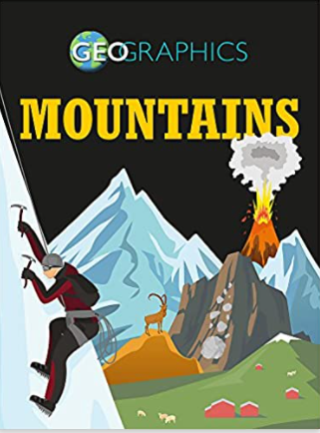  Geographics: Mountains by Izzi Howell  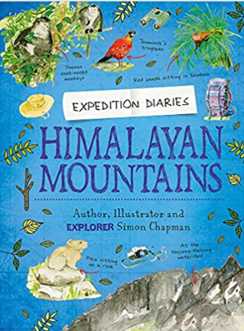  Expedition diaries: Himalayan Mountains by Simon Chapman | 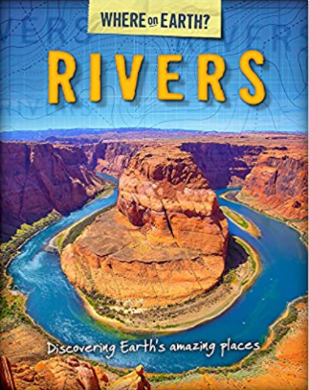  Where on Earth? Rivers by Susie Brooks  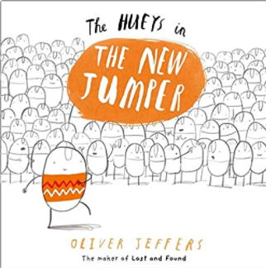  The Hueys in the new jumper by Oliver Jeffers | 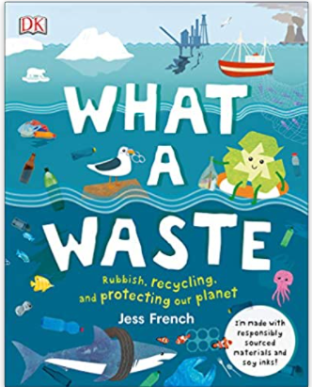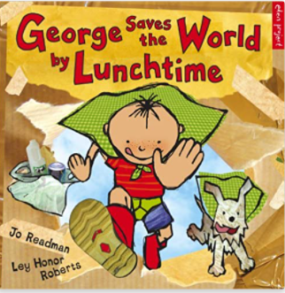  What a waste: Rubbish, recycling and protecting our planet by Jess French  George saves the world by lunchtime by Dr Jo Readman  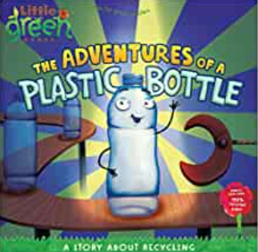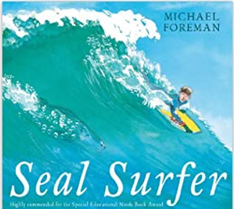  The adventures of a plastic bottle: a story of recycling by Alison Inches  Seal Surfer by Michael Foreman
Bedtime Box: your child will bring home the classes Bedtime Box during the course of the year and will read one or more of the following classic stories:
Heidi, The Secret Garden, Robin Hood and The Wind in the Willows.

