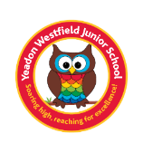
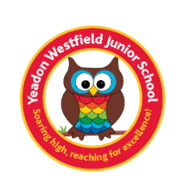
Year 5 Book List
We know that as parents, you love to read to your children and for them to read to you so we have created a book list that has lots of exciting, new books that your child will love to read as well as books that tie in with the topics they will be studying across the year at school. Each half term, the children will read a main topic book in class that links to their writing work and the topic (this is indicated in blue below). You are more than welcome to read this book with your child but it is one that will be read and studied in class as well.
Autumn 1 | Autumn 2 | Spring 1 | Spring 2 | Summer 1 | Summer 2
Ancient Greece |  | The Anglo – Saxons and Scots | Earthquakes | South American (focussing on Brazil) | Eco-Schools  Biodiversity and  School grounds project
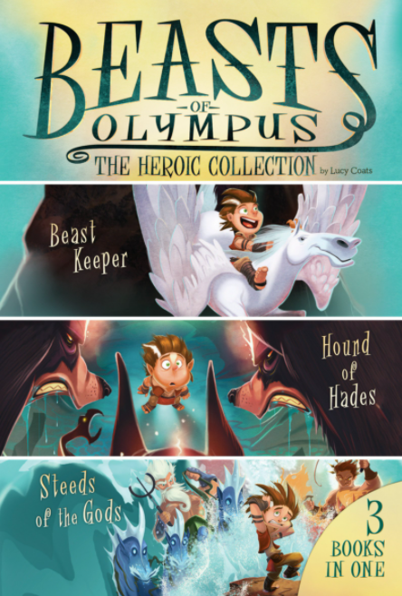  Beasts of Olympus: The Heroic Collection  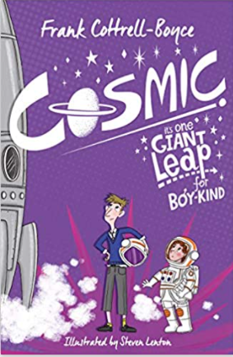  Cosmic by Frank Cottrell-Boyce |  | 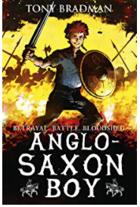 Anglo-Saxon boy by Tony Bradman | 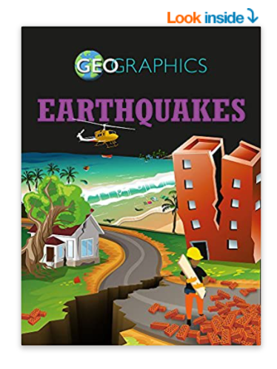  Geographics: Earthquakes by Georgia Amson - Bradshaw  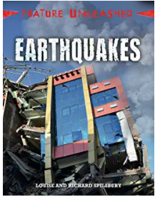  Nature Unleashed: Earthquakes by Louise Splisbury and Richard Splisbury | 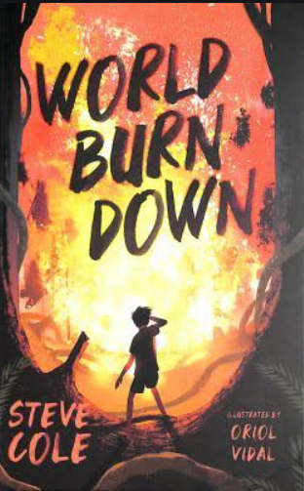World Burn Down  Steve Cole | 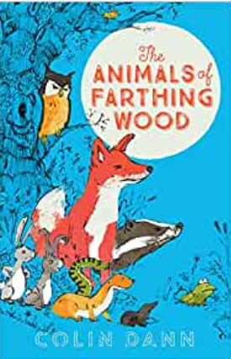  The Animals of Farthing Wood by Colin Damm
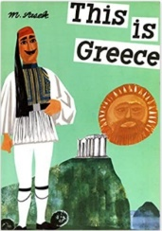  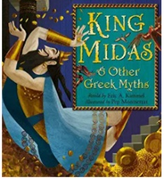  This is Greece: Miroslav Sasek  King Midas and other Greek myths by Eric A. Kimmel and Pep Montserrat  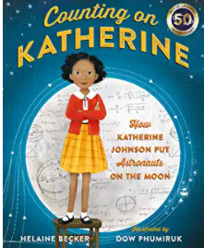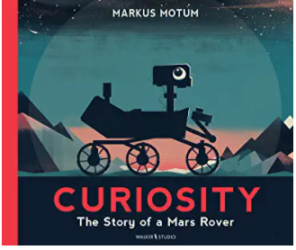  Counting on Katherine by Helaine Becker  Mars Rover: Curiosity The story of a Mars Rover |  | 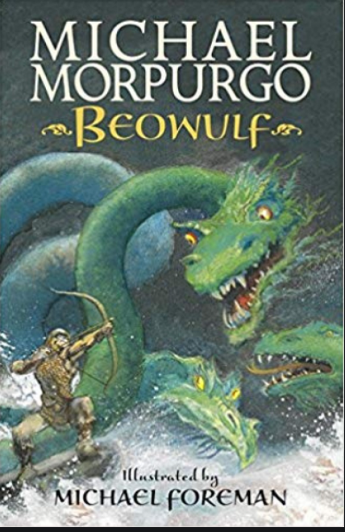  Beowulf by Michael Morpurgo  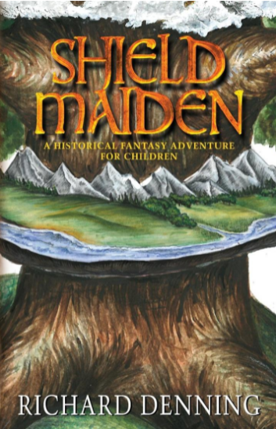  Shield Maiden by Richard Denning | 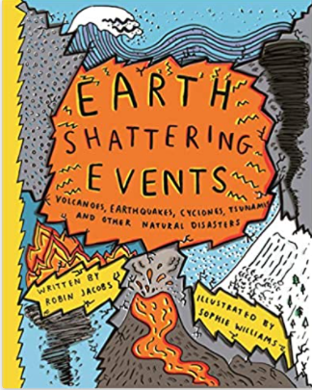  Earth Shattering  Events by Sophie Williams | 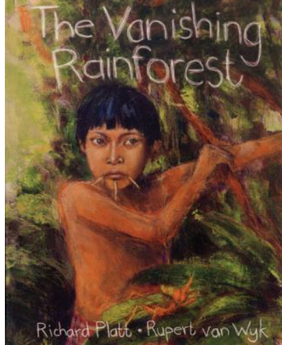  The Vanishing rainforest  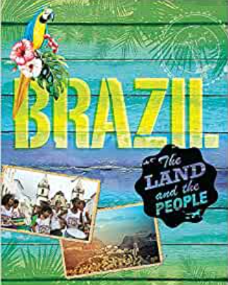  Brazil by Susie Brookes | 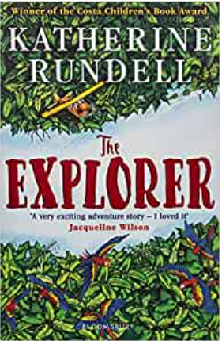  The Explorer By Katherine Rundell  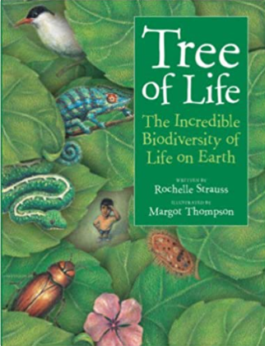  The Tree of Life by Rochelle Strauss
Bedtime Box: your child will bring home the classes Bedtime Box during the course of the year and will read one or more of the following classic stories:
Anne of Green Gables, Oliver Twist, Robinsoe Crusoe and The Jungle Book.

