Week 3 given out 2/06/2025
Term 2B started
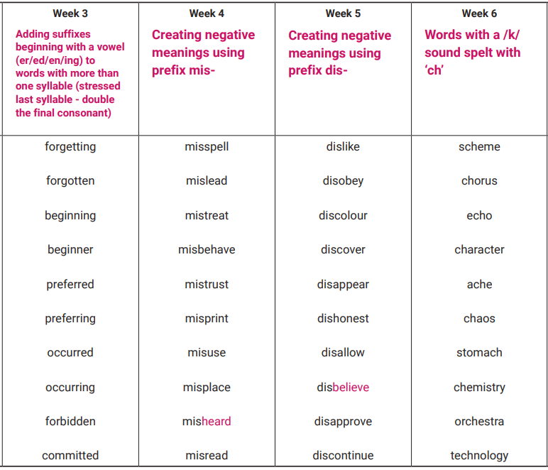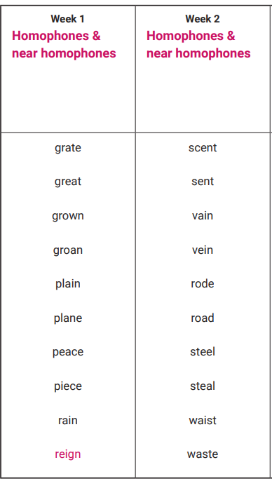
Tested Mon 14th July

Tested Mon 7th July

Tested Mon 30th June

Tested Mon 23rd June

Tested Mon 16th June

Tested Mon 9th June

