Week 1 given out 17/03/2025
Term 2A started
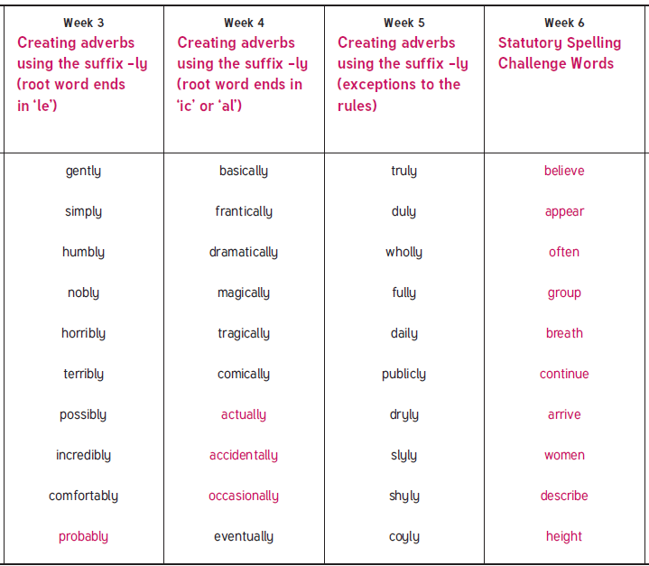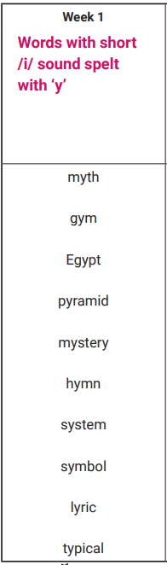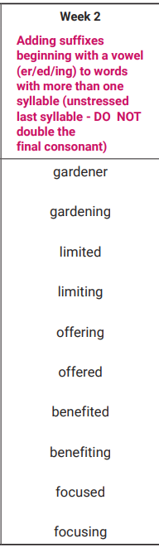
Tested Mon 2nd June (Summer 2)
Tested Mon 19th May
Tested Wed 23rd April
Tested Mon 12th May
Tested Tue 6th May
Tested Mon 28th April

