A Parents’ Guide to The Zones of Regulation

The Zones of Regulation is an internationally renowned intervention which helps children to manage difficult emotions, known as ‘self-regulation’.
Self-regulation is best described as the best state of alertness for a situation. For example, when your child takes part in a sports game, they would need to have a higher state of alertness than when, for example, they were working in a library.

From time to time, all of us (including adults) find it hard to manage strong feelings such as worry, anger, restlessness, fear or tiredness, and this stops us from getting on with our day effectively. Children who feel these emotions often find it hard to learn and concentrate in school. The Zones of Regulation aims to teach children strategies to help them cope with these feelings so they can get back to feeling calm and ready to learn. These coping strategies are called ‘self-regulation’.

We are using the Zones of Regulation in school alongside our Thrive programme. We want to teach all our children good coping and regulation strategies so they can help themselves when they experience difficult situations in and out of school. Teaching them how to cope with these feelings might improve their ability to tackle learning challenges and build better resilience so they don’t give up so easily.
Teaching the children at a young age about managing their feelings will support them in later life and enable them to choose positive coping strategies to boost mental and physical wellbeing. The children will learn that everyone experiences all the Zones at one time or another and that no Zone is bad.

We aim to help children to:

• Recognise which Zone they are in and learn how to change or stay in the Zone they are in.
• Increase their emotional vocabulary so they can explain how they are feeling.
• Recognise when other people are in different Zones, thus developing better empathy.
• Develop an insight into what might make them move into the different Zones.
• Understand that emotions, sensory experiences such as lack of sleep or hunger and their environment might influence which Zone they are in.
• Develop problem-solving skills and resilience
• Identify a range of calming and alerting strategies that support them, a ‘toolkit’.

What are the different Zones?
Blue Zone: low level of arousal; not ready to learn; feels sad, sick, tired, bored, moving slowly.
Green Zone: calm state of alertness; optimal level to learn; feels happy, calm, feeling okay, focused.
Yellow Zone: heightened state of alertness; elevated emotions; has some control; feels frustrated, worried, silly/wiggly, excited, loss of some control.
Red Zone: heightened state of alertness and intense emotions; not an optimal level for learning; out of control; feels mad/angry, terrified, yelling/hitting, elated, out of control.
How can you help your child use The Zones of Regulation at home?
- Identify your own feelings using Zones language in front of your child (e.g.: I’m frustrated. I think I am in the Yellow Zone.”)
- Talk about what tool you will use to be in the appropriate Zone (e.g.: “I need to take four deep breaths because I am in the Red Zone.”)
- At times, wonder which Zone your child is in, or discuss which Zone a character in a film/book might be in. (e.g.: “You look sleepy. Are you in the Blue Zone?”)
- Engage your child in discussion around Zones when they are in the Red Zone is unlikely to be effective. You need to be discussing the different Zones and tools they can use when they are more regulated/calm.
- Modelling is important. Show the children how you use tools to help yourself when in the Blue Zone. For instance, you might say “I am going to make myself a cup of tea and do some breathing exercises because I am in the blue zone” and afterwards tell your child how using those tools helped you feel better.
- Share how their behaviour is affecting your Zone. For example, if they are in the Green Zone, you could comment that their behaviour is also helping you feel in the Green Zone.
- Put up and reference the Zones visuals and tools in your home (find one on our website).
- Praise and encourage your child when they share which Zone they are in.

Tips for practicing the Zones of Regulation
- Know yourself and how you react in difficult situations before dealing with your child’s behaviours.
- Know your child’s sensory threshold. We all process sensory information differently and it impacts our reactivity to situations.
- Know which situations bother your child.
- Be consistent in managing your child’s behaviour.
- Empathise with your child and validate what they are feeling.
- Have clear boundaries/routines and always follow through.
- Do not deal with an angry, upset child when you are not yet calm yourself.
- Discuss strategies for the next time when you are in a similar situation.
- Praise your child for using strategies.
- Encourage your child to take a sensory break to help regulate their bodies.
- Create a ‘calm’ box full of things which help to keep your child calm and alert. Advice about what could go in the box can be found on our website in the ‘Zones Toolkit’ section.

Common questions on the Zones of Regulation
Can my child be in more than one zone at the same time?
Yes. Your child may feel tired (blue zone) because they did not get enough sleep, and anxious (yellow zone) because they are worried about an activity at school. Listing more than one Zone reflects a good sense of personal feelings and alertness levels.

Should children be punished for being in the RED Zone?
It’s best for children to experience the natural consequences of being in the RED zone. If a child’s actions/choices hurt someone or destroys property, they need to repair the relationship and take responsibility for the mess they create. Once the child has calmed down, use the experience as a learning opportunity to process what the child would do differently next time.

Can you look like one Zone on the outside and feel like you are in another Zone on the inside?
Yes. Many of us “disguise” our Zone to match social expectations. We use the expression “put on a happy face” or mask the emotion so other people will have good thoughts about us. Parents often say that their children “lose it” and goes into the Red Zone as soon as they get home. This is because children are increasing their awareness of their peers and expectations when in the classroom. They make every effort to keep it together at school to stay in the Green Zone. Home is when they feel safe to let it all out.

Where can I find out more about the Zones of Regulation?

www.zonesofregulation.com

www.weareteachers.com/zones-of-regulation-activities

https://www.theottoolbox.com/?s=zones+of+regulation

The Zones of Regulation - An Overview of The Zones for Parents (hes-extraordinary.com)

Tools to help your child to regulate their emotions in each Zone
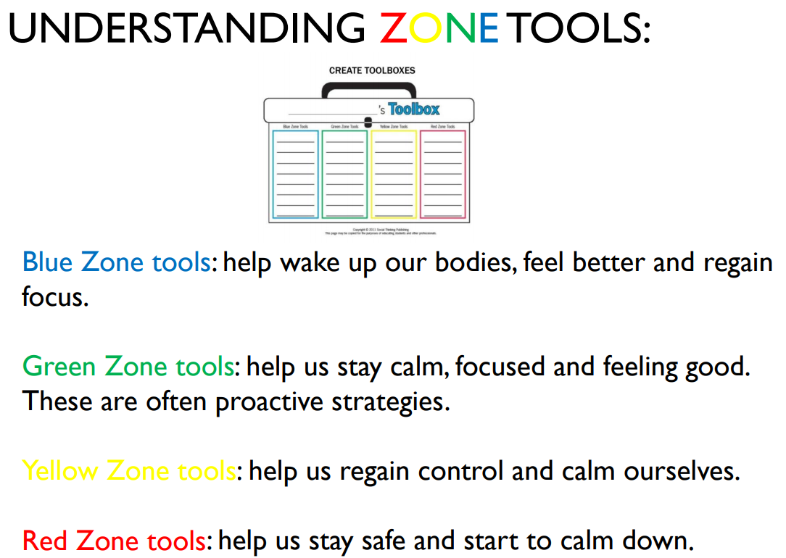

These ‘tools’ aren’t just for school: they can be used at home too so you can help your child to regulate (manage) their emotions.
Read through some of the strategies below to decide what would go in your Zones of Regulation toolkit? Think about:
- What helps you to calm down when you are stressed?
- What helps you to focus when you are tired?
- What do you do to calm down when you are angry?
Different tools work for different people. Can you help your child choose what works for them when they need to move from one zone to another?
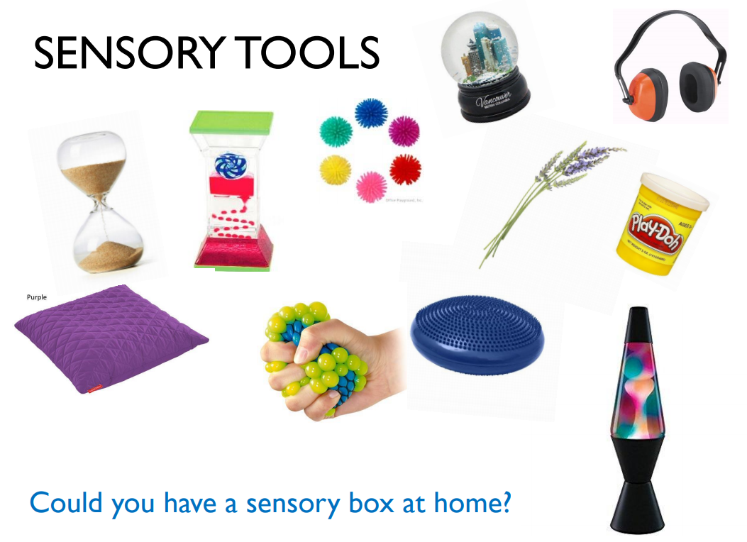
Sensory tools include anything which you can see, touch/feel, smell, hear or taste. They also are things which encourage you to move, such as

- Having a bear hug
- Using a wobble cushion
- Using a weighted toy or blanket
- Ear defenders / headphones
- Blowing bubbles
- Watching changing coloured lights
- Soft, dimmed lighting
- Fidget and squeezy toys or putty
- Smelling relaxing scents like Lavender
- Eating chewy food
- Swinging or rocking
- Eating a strong mint
- Wall push-ups
- Sucking a smoothie or milkshake through a straw
- Roll on a balance ball
- Listen to classical music
- Have a dance
- Jumping on a trampoline
- Having a nice warm bath
- Listening to bird / nature sounds
- Going for a walk or run
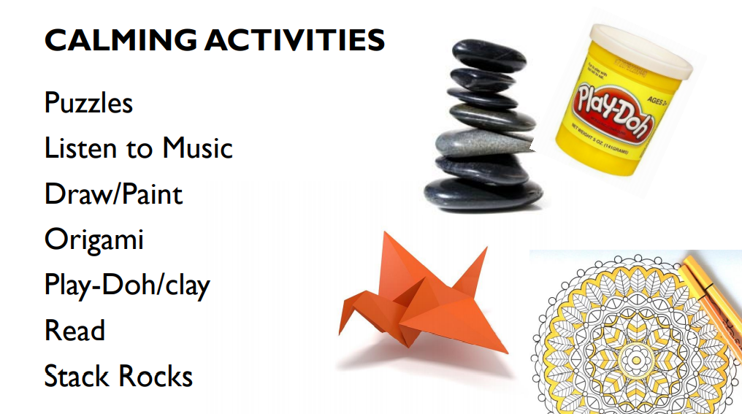

These include any activities which distract you or need you to focus to take your mind off worries and negative thoughts.

Thinking Techniques

These are strategies to challenge negative thoughts and help a child to deal with problems.
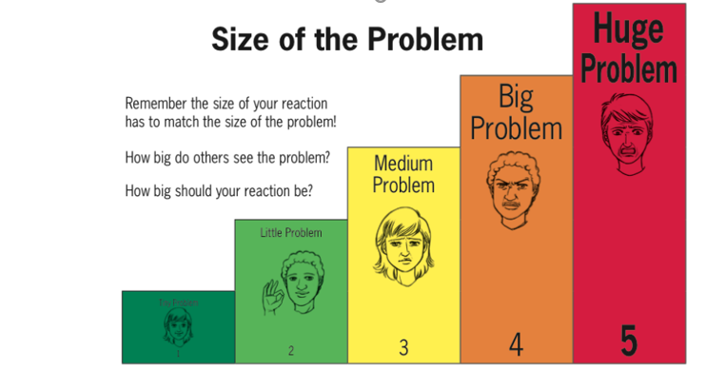
Make sure you frequently praise your child for having expected reactions rather than just pointing out the unexpected reactions.

Inner Coach versus Inner Critic

Instead of…. | Try thinking….
I’m not good at this! | What am I missing?
I give up! | I just need to find the right way for me.
This is too hard! | This might take some time and effort.
I can’t make this any better! | I will keep trying.
I can’t do it! | I can’t do it, yet.
I made a mistake! | Mistakes help me learn.
It’s not good enough! | If I have tried my best, it’s good enough.

Breathing Techniques
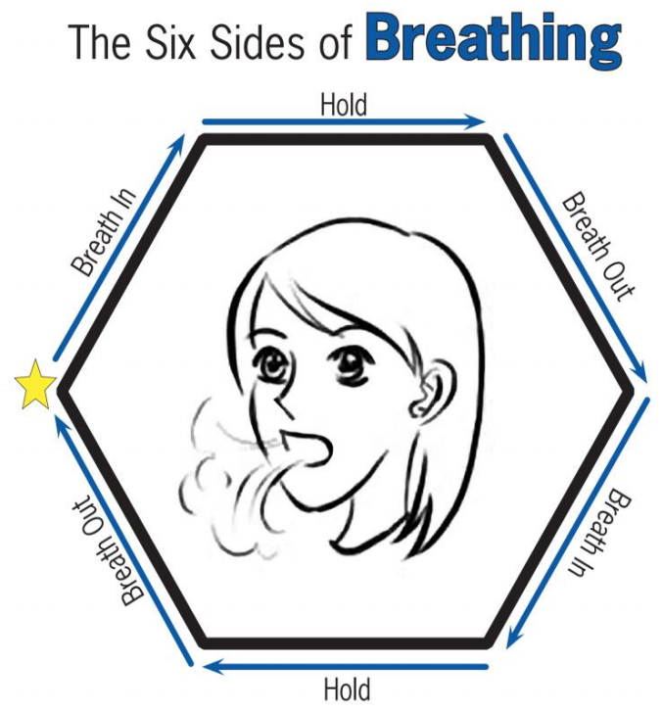
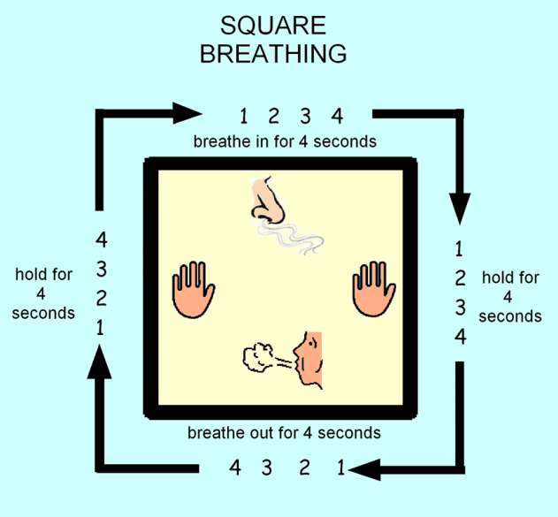
Starting at the star, trace with your finger the sides of the hexagon as you take a deep breath in, feeling your shoulders rise as the air fills you. Trace over the next side as you hold your breath for a moment. Slowly breathe out as you trace the third side of the hexagon. Continue tracing around the bottom three sides of the hexagon as you complete another deep breath. Continue the Six Sides of Breathing cycle until you feel calm and relaxed.

Grounding Techniques

Grounding techniques can help someone who is extremely anxious or scared, has lost control and is struggling to calm down.


5-4-3-2-1 Senses
Identify:

- 5 things you see
- 4 things you hear
- 3 things you smell
- 2 things you can touch
- 1 thing you taste

5-4-3-2-1 Sights
If noticing each sense is tough right now, try an exercise just with sights. Create categories and have them name what they see. Here’s an example:

- 5 colours I see
- 4 shapes I see
- 3 soft things I see
- 2 people I see
- 1 book I see

A-B-C Around the Room
This exercise will get the child connected with that place where they are right now. Have your child look around the room and name something they see that starts with A, then B, then C and so forth. See how far they can get through the alphabet and then check-in to see how they’re feeling once they reach the end.

Object Focus
Keep some unique items on hand with different textures and colours. These could be sensory items, colourful rocks, snow globes or something else. Children can hold an item in their hands and fully focus on the item. Notice the colours. Notice the textures. How does it feel in my hand? How does it feel when I squeeze it? What colours do I see? Just notice everything there is to notice about the item!

‘I am Here’ Hand Trace
For this exercise, you’ll need paper and a pencil, marker, or crayon. Children will trace a hand on the paper. You can take this a few different directions. Children can simply press the hand into the space on the paper and feel the connection between hand and table. Alternatively, they can use the space inside the hand to write things they see or describe the room.

Reorientation
To re-orient to the moment, just have your child name facts about the moment. You can give them a card to keep with them to remind them of facts they can state and practice, practice, practice! It might sound like:

- My name is…
- I am in…
- Today is…
- The season is…
- The weather is…
- I am wearing…

Room Search
Pick one broad category and search the room. Name everything in the room that is green. How many stars can you find in the room? Say the type of shoe everyone in the room is wearing. Count the bricks on one wall.

