YEADON WESTFIELD JUNIOR SCHOOL
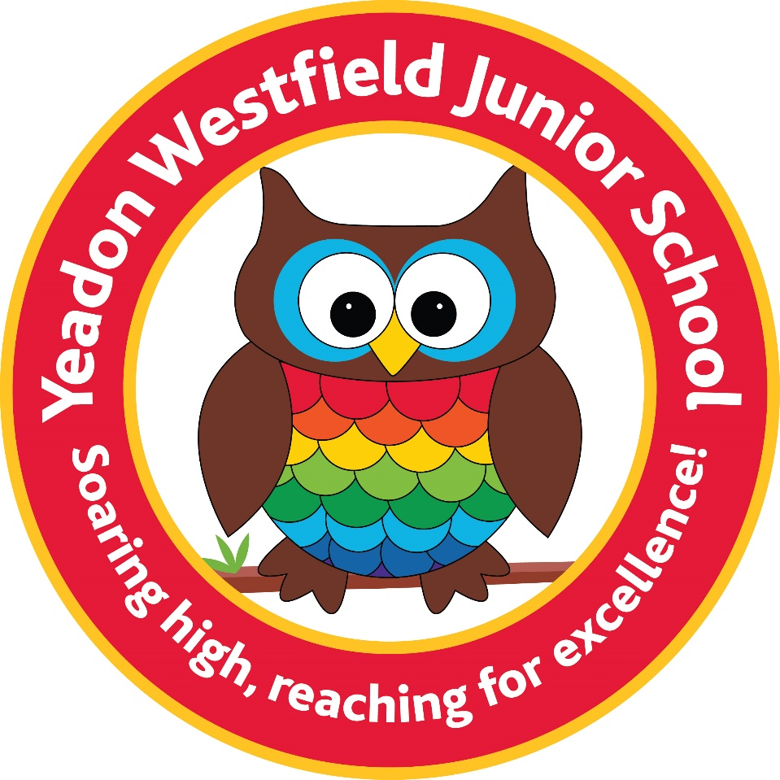

COMMUNICATION POLICY
January 2023
This policy has been adopted from the recommended DfE Communication Policy.

This school is committed to safeguarding and promoting the wellbeing of all children and expects our staff and volunteers to share this commitment.We believe that every person has a fair and equal opportunity to succeed, regardless of their age, gender, ethnicity, ability or cultural or religious background, sexuality or disability. We embrace all aspects of global citizenship and community cohesion, promoting British Values throughout all aspects of school life, actively tackling prejudice or extreme views.

Yeadon Westfield Junior School is required to keep and process certain information about its staff members and pupils in accordance with its legal obligations under the General Data Protection Regulation (GDPR). The school may, from time to time, be required to share personal information about its staff or pupils with other organisations, mainly the LA, other schools and educational bodies, and potentially children’s services. This policy is written in line with our agreed policy for GDPR.

Overview
It is very important to us that we work closely in partnership with parents and carers, and communication between home and school is key. We recognise however that it can often be difficult communicating with staff because they have a very full timetable; and we recognise that parents and carers also have very busy lives.

Contacting the School
Teachers want to respond to parental queries at the earliest opportunity and will do their best to do so, however, the majority of teachers’ time is taken up teaching and preparing for lessons. Teachers’ responsibilities extend beyond the classroom, and they may be unable to respond to you on the day a query is made. We have also agreed with staff that there is no expectation to respond to queries during their personal/family time. Communication by telephone or an email to the office are our preferred methods of communication.

Telephone
Please use the main reception number (0113 2503395) to leave a message briefly outlining the reason for your call:
- Reception staff will relay messages to teachers as soon as possible.
- If a call is urgent, please inform the receptionist who will attempt to find a senior member of staff to speak to you.
- We will try to respond to you within 2-3 working days, if not the same day, either by a return phone call or an email.
- Please note lessons will never be interrupted for teachers to take calls.

Email
Please use the office email address ‘office@yeadonwestfieldjuniorschool.co.uk’ if you need to contact staff:
- Teachers are not in a position to check emails consistently throughout the day and the school does not expect work emails to be checked during a teacher’s personal time.
- We aim to respond to you as soon as possible and within 2-3 working days. Part-time staff may take longer to reply.

Meetings
The day-to-day care, welfare and safety of your child is managed by the person who is placed closest to them.
- In the first instance, please approach the following members of staff who are responsible for your child in the following order:
- Class teacher.
- Deputy Headteacher/Headteacher

- Meetings should always be pre-arranged with members of staff.
- If you urgently need to see someone, for instance if there is a serious family emergency or a child protection issue, please phone ahead and the reception staff will do their best to find a senior member of staff to see you.
- For non-urgent meetings we will aim to meet with you within five working days. The school will determine the level of urgency at its discretion, to enable it to manage multiple demands.

Contacting You
Our preferred method of contacting you is via text message and email using Teacher2Parents. We will also contact you by phone if applicable. All information about up and coming events and news you need to know can be found in our school newsletter, this is emailed to all parents on a Friday or can be found on the homepage of the school website. All trip letters are sent to parents via email. If you require paper copies of any letters, these can be requested from the office.

School Website
We use our school website and Facebook page to promote student achievements, subject information and generic educational information. Dates of up coming events are always found on the school newsletter. Homework timestables and copies of weekly spellings are found in each year group page on the website.
School Office
Please note that the school office hours are between 8.30am and 4.30pm.

No Response
If you have not received a response from the school within three working days please contact the school by emailing, office@yeadonwestfieldjuniorschool.co.uk and we will chase up your enquiry. Communication with parents and carers is important to us, and we will continue to monitor this policy and our approach to improve the process further.
In Conclusion
Yeadon Westfield Junior School staff are always keen to meet with and work in partnership with parents/carers. We operate an "Open Door" approach meaning that we welcome any communication that improves school life and the education and welfare of the children at Westfield, though the best way to communicate with us is outlined above.

We aim that meetings will always take place in a positive atmosphere with the mutual interests of the pupil in mind. In return, staff and parents/carers are expected to behave with mutual respect between all parties. If, on the very rare occasion that it may happen, parents/carers behave in a way that is felt to be inappropriate, the meeting will be curtailed. All staff have the right to be treated with respect in an environment free from verbal or physical aggression. Repeated verbal or physically aggressive behaviour will not be tolerated.

