If you are being bullied

DO:
- Ask them to STOP!
- Use eye contact and tell them to go away.
- Ignore them.
- Walk away.
- Ask for help & support from your friend.
- TELL SOMEONE you trust straight away.
- Use your class worry box.

DON’T:
- Retaliate (do something bad to them).
- Think it’s your fault.
- Hide it or keep it a secret.
- Be a bystander.

DONT

What are your rights?
- We have the right to be happy
and not feel scared.
- We have the right to have a
good education.
- We have the right to enjoy
being at school.
- We have a right to make all the
right choices.
- We have a right to make our
school a place where everyone
can feel safe and happy.

Do NOT be a Bystander!
- Being a bystander is when you
witness bullying happening but
do not do anything about it.
Never be a bystander. Always
tell a trusted adult.

Treat others how you want to be treated

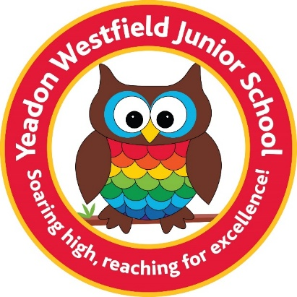

Yeadon Westfield
Junior School’s

Anti-Bullying Leaflet
For Pupils & Parents

By The Harmony Reps.

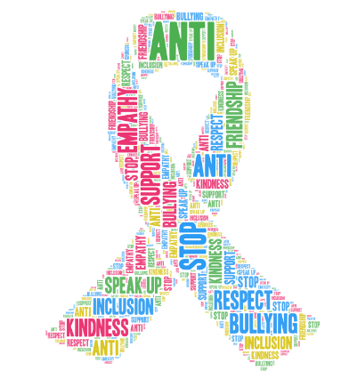

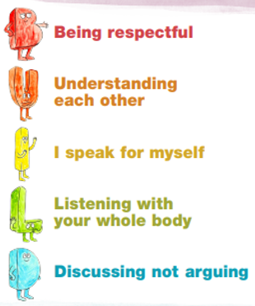

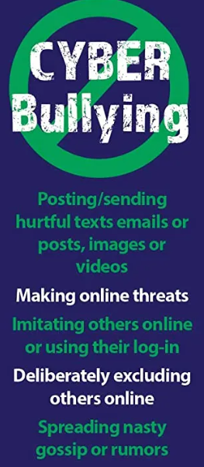
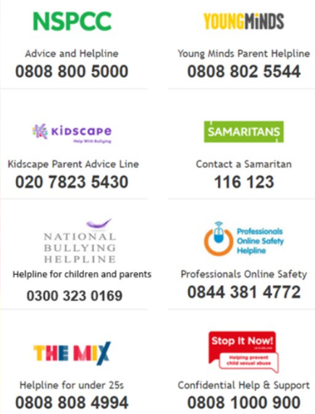
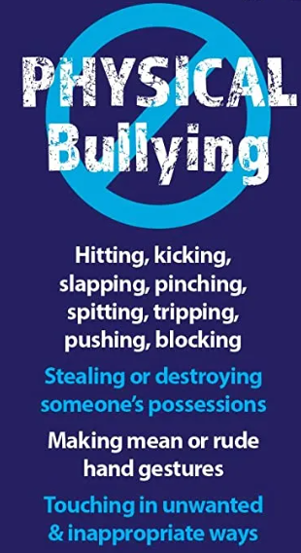
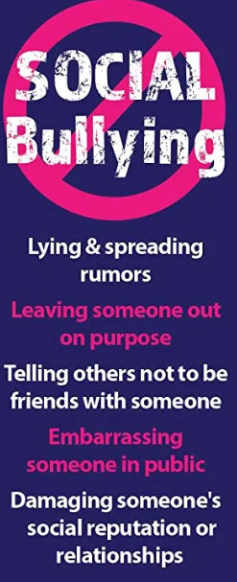
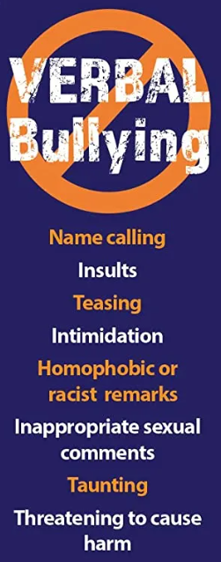

Who can I tell?
START
TELLING
OTHER
PEOPLE
- A Trusted Friend
- Parents/Carers
- Teaching Staff
- Mrs Stokey
- Harmony Rep.

What is Bullying?

Bullying is when someone hurts another deliberately more than once.

When does Bullying happen?
SEVERAL
TIMES
ON
PURPOSE
Bullying is conscious, deliberate and calculated. It is usually repeated over a period of time. The behaviour is repeated frequently and is not a one-off incident.
To tackle any cases of bullying, parents and schools need to work together in partnership.

We promise to always treat bullying seriously.

