Who can I tell?

Trusted Adults: If you experience or see racism, always tell a teacher, parent, or trusted adult.

School Council / Worry Box: You can write a note and put it in the class worry box.

Childline: You can call Childline at any
time to talk about anything that's
worrying you. 0800 1111

NSPCC: You can call NSPCC at any time
to talk about anything that’s worrying
you. 0808 800 5000

Emergency Services: 999 or 101

Remember
Racism is never okay. You do not have to deal with it alone. Tell a trusted adult and keep asking for help until someone listens.

P.O.W.E.R
Use your POWER to stand up to Racism
P – Proud of Differences
Everyone is unique. Be proud of your own identity and respect other people's cultures, languages and backgrounds.
O – Open to Everyone
Include everyone in games, activities and conversations. Make sure no one is left out.
W – Watch Out for Unfairness
Notice when someone is being treated unfairly because of their race, culture or background.
E – Encourage Kindness
Use kind words, support others and help make your school a welcoming place for everyone.
R – Report Racism
Tell a trusted adult, such as a teacher, parent, or carer, if you see or experience racism.

DONT

Be Kind, Be Fair: Standing Up Against Racism

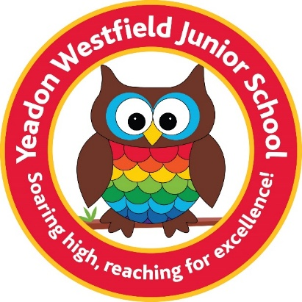

Yeadon Westfield
Junior School’s

Anti-Racism Leaflet
For Pupils & Parents

By The Harmony Reps

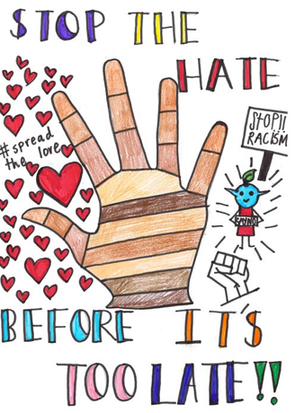
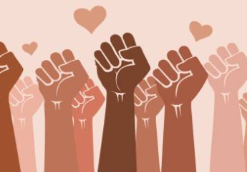

What does anti-racism mean?
Anti-racism means actively treating everyone fairly and standing up
against racism when we see it.

Racism can include:
- Calling someone names because of their skin colour or background.
- Making fun of someone's accent, language, clothes or culture.
- Excluding someone from a game because they are different.
- Sharing hurtful stereotypes or jokes.
Being anti-racist means:
- Including everyone in games and activities.
- Learning about different cultures and traditions.
- Speaking kindly to others.
- Telling a trusted adult if someone is being treated unfairly.
What is Racism?
Racism is when someone is treated unfairly, left out, teased, bullied or judged because of their race, skin colour, ethnicity, culture or where
their family comes from.

RACISM IS WRONG

Everyone deserves respect and
kindness, no matter what they look
like, where they come from or what language they speak.

How Can We Be Allies?

- Learn and Listen: Ask questions about different cultures and listen to your classmates' stories.
- Be Kind: Include everyone in your games, even if they look or act differently than you.
- Use Your Voice: Say "that's not okay" when you hear unkind comments about someone’s race or background.
- Celebrate Diversity: Our differences make our school and our community special and exciting!

