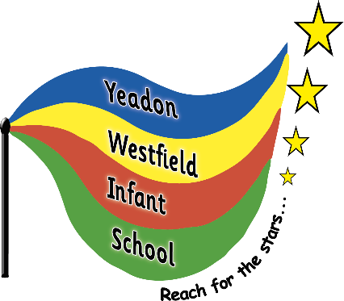
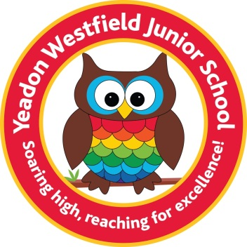

Yeadon Westfield Infant and Junior Schools – Proposed Amalgamation
Over the last 12 months, the governing bodies of Yeadon Westfield Infant School and Yeadon Westfield Junior School have been considering the long-term sustainability of both schools.
Following significant due diligence and exploration of options, both governing bodies have decided to consult on a proposal to amalgamate (merge) Yeadon Westfield Infant and Junior Schools into one primary school (age 3-11) from September 2026.
The fundamental aim of both Governing Bodies is to ensure the long-term delivery of high-quality education on the Yeadon Westfield site. With Leeds City Council choosing Aireborough as the first area to be considered under its Area Based Planning approach to future school place planning, we believe that this is now an appropriate and timely opportunity to put forward our two schools’ proposal in partnership.
Under our proposals:
Yeadon Westfield Primary School would be created as a one form entry single primary school, catering for children aged 3 to 11, from September 2026 subject to approval by Leeds City Council.
In practice this would mean extending the age range of the Infant School to include Key Stage 2 pupils (years 3, 4, 5 and 6), and closing the Junior School as a separate body. However, as all teaching staff would be retained in the first instance and the Junior School building would continue to be used, the initial years of amalgamation would feel very much the same as it does now to existing pupils.
All current pupils in the Infant and Junior Schools would have a place in the new school. There would be no need for infant children to apply for a place in the Junior School.
Children who have applied for places at the Infant School will be offered a place at the primary school.
• The new school would have a single head teacher and one business manager as part of a restructured senior leadership team.
• All teaching, support and ancillary staff would have roles in the new school.
• The Infant School’s governors would form the new primary school’s governing body. We would look for all opportunities for the Junior School’s governors to join the new governing body.
• Both school buildings would be used for teaching for the first few years, before all children move into the Junior School building as a one form entry primary school by September 2029. Both governing bodies are currently considering use of the infant building from that date. Under the law, school buildings must be retained for education purposes for eight years.
• The nursery would become part of the primary school, with some alterations to the junior school to be made to accommodate this.
Key benefits:
• With lower numbers of pupils in the area, both schools continue to face challenging budget positions which is putting the sustainability of both settings at risk. An amalgamated Yeadon Westfield Primary School would offer greater financial security for the school, providing stability for pupils, staff and the local community.
• In the initial years of an amalgamation, we would not see significant changes to staffing, building and pupil structures. A single primary school would also enable the Governing Body and Senior Leaders to plan strategically for a long-term financially secure school.
• In a climate of falling rolls and rising budget deficits, the Governors and Senior Leaders of both Yeadon Westfield Infant and Westfield Junior Schools believe that a Yeadon Westfield Primary School is the most realistic way of securing the continuation of the Yeadon Westfield site and name as the provider of education in the area.
• Both schools were rated as ‘good’ during their most recent Ofsted inspections, and by forming a single primary school we can provide a more consistent approach to teaching and learning. This offers greater continuity of learning and consistency in assessment of pupils’ progress and attainment, including vulnerable pupils and those with special educational needs and disabilities.
• Bringing the schools together would support even better tracking of pupils, allowing staff to identify pupils who would benefit from interventions as early as possible.
• Specific expertise and resources could be shared across age ranges so that pupils working outside their own age range could benefit.
• Consistent policies and procedures through pupils’ primary learning. This includes how children with special needs and disabilities are supported, school uniform, arrangements for open evening and school events, and school closure days.
• Longer-term relationships established across the school community.
• Although infant pupils transition to the Junior School successfully, research shows that reducing the number moves that the children make helps them to perform better.
• A condensed leadership and management team would offer greater overview to make the best decisions for the school as a whole, with resources being shared more effectively.
• Greater opportunities to develop staff’s expertise and experience across a wider age range, alongside sharing best practice and knowledge across the whole school.
• School inspectors would be aided in making more accurate judgements about the education children receive across ‘the whole picture’.

Why are you proposing this now?
Both the Infant and Junior School governing bodies have been jointly considering amalgamating for some time in order to secure education provision on the sites over the long-term.
Neither school is currently full and falling birth rates in the area are impacting both schools, creating financial pressures and increased costs which are issues affecting schools locally and nationally. Smaller schools can be disproportionately affected by budget pressures as they have a high proportion of fixed central and staffing costs.
As you may be aware, Leeds City Council is introducing an Area Based Planning approach to support future school place planning, to address these challenges by working together with schools to develop solutions which benefit communities. The Aireborough area is the first area to be considered under this approach.
We are sharing our well-considered proposal now to support an overall solution for the wider Aireborough area, which has been considered and shaped by both schools in partnership, as an opportunity to retain primary education on the existing site and to continually improve the education experience for children within our school community.
Why are you proposing to close the Junior School but retain the Junior School building in the long-term?
The Junior School site is preferred as it is a larger site with more play space and sports facilities. The intention is to use both sites from 2026 onwards with a view to accommodating all pupils from the Infant School on the Junior School site from 2029 with some internal adaptations and changes to outdoor space.
Both schools have a deficit budget, however the Junior School has the larger of the two schools.
What other options have been considered?
No change / remain as two schools – Remaining as two schools would not address the issue of falling pupil numbers, and the consequential impact on the school community and the budgets of each school. In smaller schools such as ours, this generally leads to heavier workloads on staff as there are fewer available to share responsibilities. The governing bodies believe that this option would leave both schools vulnerable to potential closure should falling rolls and financial challenges continue in the Aireborough Planning Area.
A federation – Federations operate as two or more maintained schools under a single governing body. Similar to remaining as two schools, this would not resolve the challenges of falling pupil numbers and consequentially smaller budgets, alongside the costs of running two school buildings compared to a single building in the long-term.
Closing both schools and opening a new school – Both schools are rated as ‘good’ so would not meet the criteria required to close them.
Next steps

An amalgamation has to follow a statutory consultation process. This initial consultation will help Governors decide whether to move to the next more formal statutory consultation stage. The final decision about whether the schools amalgamate would be made by Leeds City Council’s Executive Board.

How do I respond to this consultation?
You can state whether you support this proposed amalgamation or not by completing the consultation response form online. Please click on the link below;
https://surveys.leeds.gov.uk/s/yeadonwestfieldIJ25/
Consultation meetings for parents and carers and the community on the proposal will be held at 2.00pm on Monday 1st December 2025 at Yeadon Westfield Infant School and at 6.00pm on Thursday 4th December 2025 at Yeadon Westfield Junior School. Parents and carers of children at both schools can attend either meeting.
This will be an opportunity to seek any further clarifications on the proposal.
In the meantime, if you have any other questions regarding this proposal, please contact:
the Infant School on 0113 2505449 or email admin@westfieldinfants.co.uk
the Junior School on 0113 2503395 or email office@westfieldjuniorschool.co.uk
Translating this document and other formats
If you would like this document in another format such as large print, please contact us and we will do our best to help.
If you do not speak English and need help understanding this document, you or a friend can telephone 0113 3785945. We will then contact an interpreter. There is no charge to you for this service.

